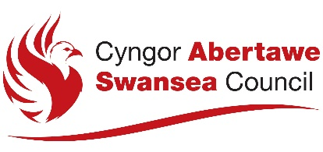

Form A for individual person or company applications

NOTICE OF APPLICATION FOR A PREMISES LICENCE

This notice is issued in accordance with regulations made under section 160 of the Gambling Act 2005

Notice is hereby given that

[Give the full name of the applicant as set out in Part 2 of the application for a premises licence]

of the following address:

Postcode

[Give the full address of the applicant as set out in Part 2 of the application for a premises licence]

the number of whose operating licence is /

who applied for an operating licence on

[Delete as appropriate. Insert the reference number of the applicant’s operating licence (as set out in the operating licence). Where an application for an operating licence is in the process of being made, indicate the date on which the application was made.]

has made an application for a premises licence.

[Insert here the kind of premises licence being applied for]

The application relates to the following premises:

[Give the trading name to be used at the premises, and the address of the premises (or, if none, give a description of the premises and their location).]

The application for a premises licence has been made to the following licensing authority:

The Licensing Division
Housing and Public Protection
Directorate of Place
City and County of Swansea
Civic Centre
Oystermouth Road
Swansea
SA1 3SN

www.swansea.gov.uk

Information about the application is available from the licensing authority, including the arrangements for viewing the details of the application.

The following person connected with the applicant is able to give further information about the application:

[This entry is optional and is to be included if the applicant wishes to provide the name, telephone number and (if available) e-mail address of a person connected with the applicant who is able to answer questions and provide further information about the application.]

Any representations under section 161 of the Gambling Act 2005 must be made no later than the following date:

[Please insert last day on which representations may be made in relation to the application. The period for making representations is 28 days (inclusive) starting with the day on which the application for the premises licence was made to the licensing authority.]

