Killan Community Solar

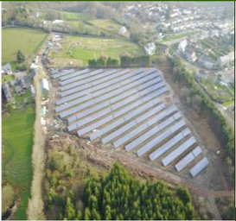

The Killan Community Solar project is a £1 Million solar scheme. Its’ aim is to run a Sustainable development measuring its success against economic, social and environmental indicators.

This project is the first of its kind in Wales. It generates clean electricity and sells that same electricity to make money which is reinvested in the GHC broader objectives, benefitting the Gower, its’ visitors’ and residents’ alike.

The solar project creates enough electricity for up to 300 houses and generates money and investment opportunities for the people living in the area, with profits going to a local charity to deliver social objectives on the Gower.
It is envisaged that over the next 30 years, this project will generate revenue of which 20 years is subsidised under the Renewables Obligation Certificates.

Project Information:

Total Project Cost: | £6,000
Total EU/Welsh Government Funding: | £4,500

Mae’r ddogfen hefyd ar gael yn Gymraeg
This document is also available in Welsh

