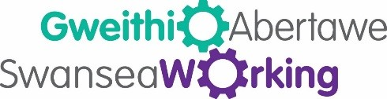

First Impressions Guide

- How do I see my own first impression?
- How should I present myself at interview and in work?

It’s true, first impressions count.

How we take care of ourselves is how other people initially see us. It is not just about what clothes you wear (although it’s always best to be smartly dressed, rather than too casual). It’s about what care you give yourself.

You will want to turn up to an interview or new job feeling fresh, energised and with value. Your value will be seen in your body language also.

Feeling good about yourself on the inside also plays an important role here and taking care of yourself on the outside will help with this.

Make time to shower and groom yourself. Plan ahead and enjoy the time you take to do this. Book an appointment with a hairdresser, run yourself a nice hot bath or shower the night before an important interview or if you intend to start a new job. Enjoy the experience.

Think about your overall appearance from head to toe regularly.

Consider the following:

- Well kept clean cut hair
- Fresh glowing skin. Subtle makeup is always best.
- Clean, smart and neutral colour clothing, finished off with presentable shoes
- Clean hands and well-kept nails
- Facial hair should be kept groomed, subtle and well-shaped

If you are a smoker, then avoid a last minute cigarette before you make that first impression. You might think you can mask the smell with chewing gum and perfume or aftershave but you can’t unfortunately.

On the subject of scent, obviously it’s really important to smell pleasant but don’t wear too much aftershave or perfume. Just wearing deodorant is perfect for the work environment.

Candidates and employees who present themselves well will make a good first impression. They will be offered employment and promotions. They will go on to represent their teams and organisations, because their employers know they can be relied upon to turn up looking professional and approachable.
Facebook: Gweithio Abertawe-Swansea Working
Twitter: @AbertaweWorking
Telephone – 01792 578632

