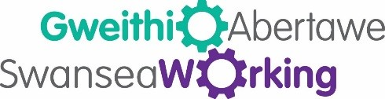

Continuous Professional Development
Guide

Testing your competency at work is essential. It allows you to see your capabilities. Stay focused on developing yourself with the aim of being able to help others. This will guide you in the right direction and it also shows you that maybe it’s time you should progress and start reaching for higher goals you may have.

‘Much to learn, you still have.’ - Yoda
Every good leader will have development plans in place for the year ahead. If you attend monthly, quarterly or yearly reviews, make sure you treat these times as a health check, not only for yourself but for support to the organisation.

Recognise the skills and abilities you have to offer in your current job and look at upskills or re-skilling to help you and the organisation to develop.

Take time to evaluate developments in your work sector. Look at the competition in your area and inspire new developments to capture an audience. Stay on top of key areas of your role especially in the digital age. Take advantage of a growing ‘online’ work society and set your goals to inspire the next generation looking at entering your career path.

Stay Positive

Everyone has days when they feel that they maybe can’t go on as they are in their current job role or they take their job for granted. If you begin to feel this way, then find support where your issues lay and explain how you are feeling to your manager.

If you are doing well in your career or feel you need to improve, you can develop with accredited CPD. Speak to Swansea Working about finding in work support for you, if you feel you don’t have any. There are people out there that really do want to help.

Swansea working can help analyse your own role, responsibilities and boundaries in the organisation. Do you feel valued as an individual? Are you able to reflect on any bad decisions and grow from them positively? A supportive work environment can make the world of difference to your development.

We can help support you. All you have to do is ask.

Facebook: Gweithio Abertawe-Swansea Working
Twitter: @AbertaweWorking
Telephone – 01792 578632

