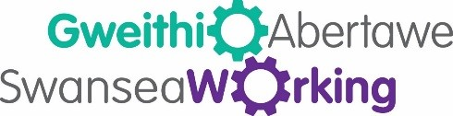

Career Wheel

Your journey in becoming a more employable you

- Ask for help

Everyone needs help in order to move forwards. Finding fault is not a negative. It’s your chance to inspire change in yourself and others. Without finding faults it is difficult to grow. Ask yourself; what help do I need? Where can I find help? What changes and training do I need to progress?

- How do I see my strengths and weaknesses?

Start with listing your strengths in order to find balance against your faults. Sometimes this is difficult, however, asking for help and wanting to develop yourself is a huge strength in itself. Sometimes it takes others to identify your strengths with you. Once you identify your strengths and weaknesses you can focus on these in order to grow.

- How do I look or present myself?

Think about how you present yourself on paper, face to face and online - (CV, cover letter, applications, interviews and online).

How we present our strengths is important to move forward in life and career. You want to represent yourself in the best light and let others know you are the best you, you can be. Showing strength however is very difficult at times but with practice you can do it.

- How do I start to make changes?

Plan what you want to achieve by gathering information with a professional on your chosen progression route and make this your goal and plan to move forward. Support is always there to help you achieve this.

Having planned your progression route, don’t rush this process in order to move forward. Start at your own pace and trust in your belief that you will reach the finish line with your learning and development.

Take time to start addressing your changes and build your skill set.

- How do I apply my new skills?

Start to apply your new skills and strengths into your career. Focus these skills on getting employed or progressing in your current employment or make a step forward on your dream path.

- How do I stay in my job or progress in my career?

Staying power or Continued Professional Development in work comes down to your performance and drive. It lets others know that you were the right person for the job, however, improving yourself and continuing to develop is also important.
The career circle is endless if you have the will power to succeed. Move forward by taking a step back (to stage one) and begin the process all over again.

