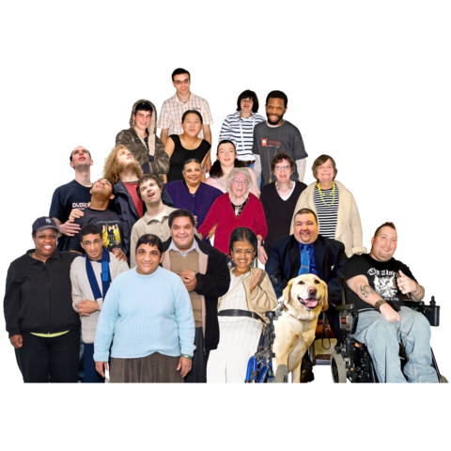
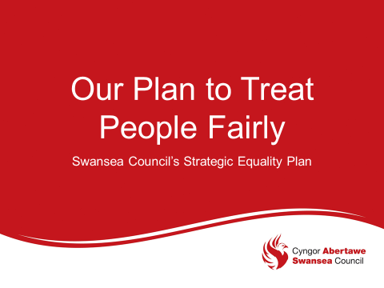

The full version of this Easy Read can be read online at www.swansea.gov.uk/sep

What is a Strategic Equality Plan?

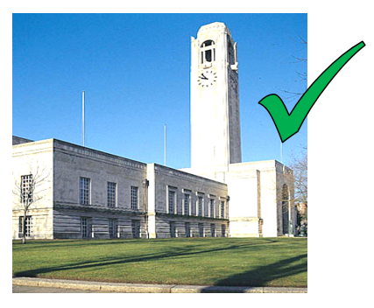 | At Swansea Council we want Swansea to be a fairer place
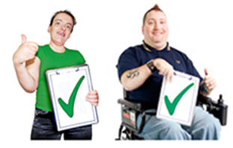 | Equality is about treating people fairly
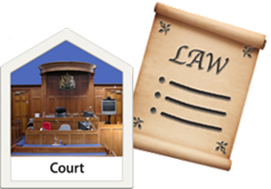 | The law says the Council must have a Strategic Equality Plan to treat all people fairly
Treating everyone fairly means Everyone has the right to get the things they need to
- be well
- be safe
- feel respected

Why we have a Strategic Equality Plan

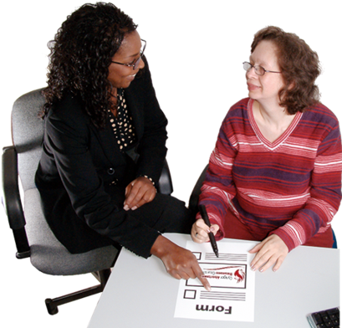 | Swansea Council wants everyone to find our services easy to use.
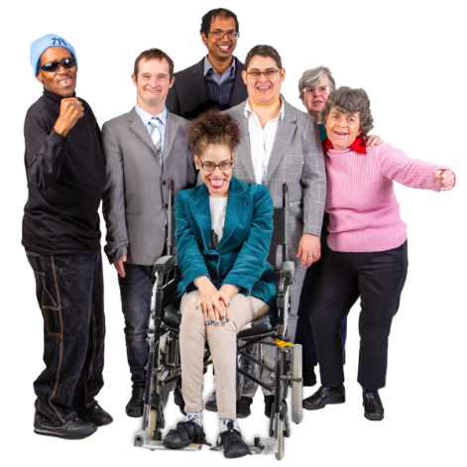 | We want everyone to take part
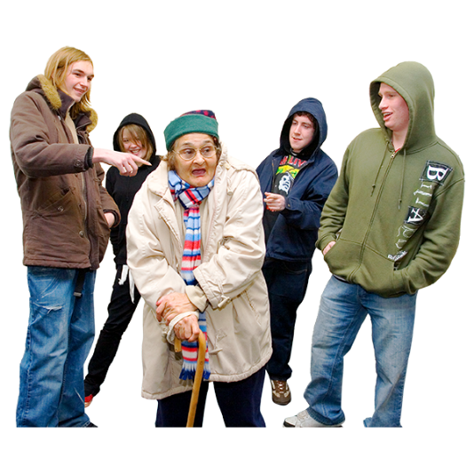 | No one should face discrimination  Discrimination is when someone treats you unfairly because they think you are different.
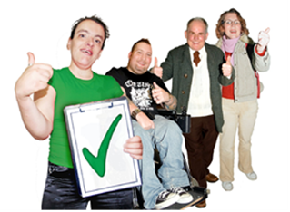 | Our Plan makes sure we think about people who are most likely to be treated unfairly
How we wrote our Strategic Equality Plan

 | We found out lots of facts and information about people that live in Swansea and how they are different from each other
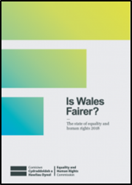 | A Report called  ‘Is Wales Fairer?‘ told us about equality and fairness in Wales and what needs to change
 | We listened to people and asked what they thought including people who are most likely to be treated unfairly
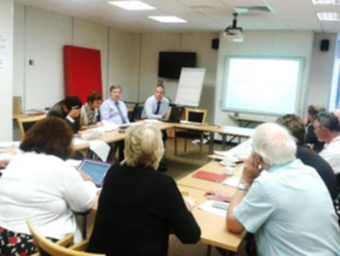 | Scrutiny is a way for the people we vote for to check good decisions are being made.  People, experts and groups are asked about a subject and what should be done better is agreed
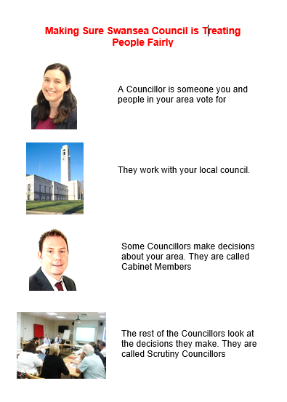 | In 2018 and 2019, Swansea Council Scrutiny looked at how they can make things fairer for people in Swansea  Lots of people, groups and experts took part. The things that it was agreed should happen are in this Plan
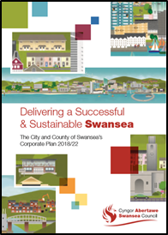 | Our Corporate Well-being Plan is about what the Council plans to do to make life better in Swansea  It is linked to our Strategic Equality Plan. This means we think about equality in everything we do

Our Equality Objectives

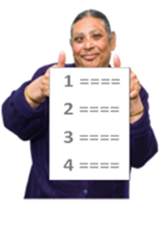 | Equality Objectives are goals that the Council will work towards to make Swansea fairer
 | We will do these things by 2024
Education – Equality Objective 1

Education

This means
 | We will work together to make sure learning is a good experience for everyone
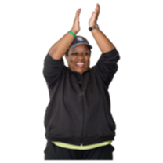 | We want to make sure everyone has a fair chance to do well
 | We will
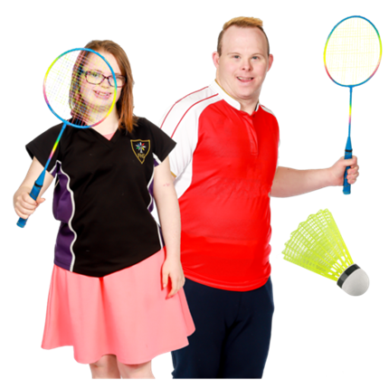 | Make sport in school fair for boys and girls
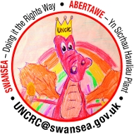 | Help young people understand their rights and how to be a good citizen
 | Help people get skills and look for ways to offer different types of work
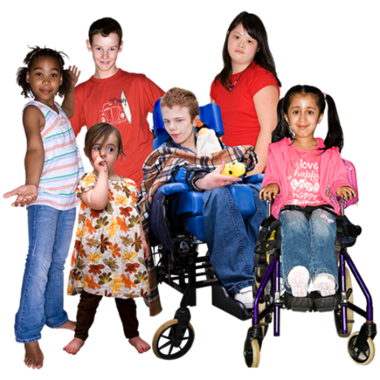 | Improve school buildings to meet people’s needs

Work – Equality Objective 2

Work

This means
 | We will work to make sure people are paid fairly
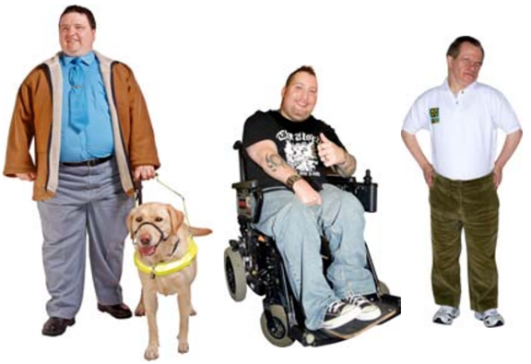 | We want to make sure everyone has a fair chance to work
 | We will
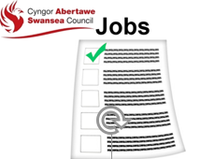 | Look at how the Council gives people jobs and make sure it is done fairly
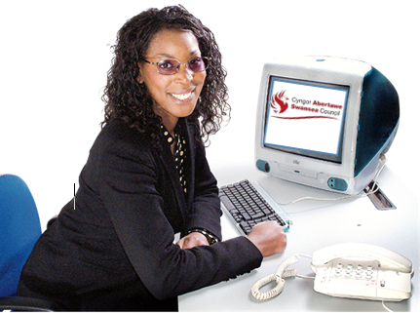 | Make sure Council staff are trained to treat people fairly
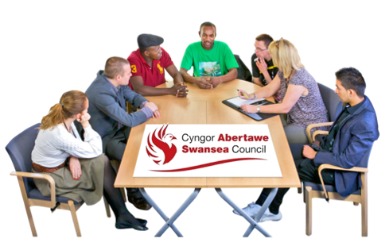 | Put together a group of people to make sure the Council is fairer in the future

Living Standards – Equality Objective 3

Living Standards

This means
 | We want to help poor people
 | We want to help people, live their best life without the help of others where it is possible
 | We will
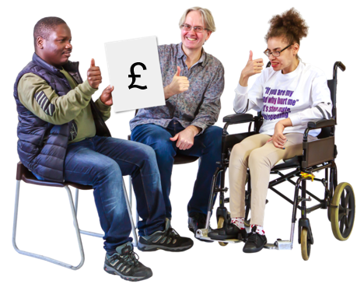 | Ask people who have been or are poor what can be done to change things
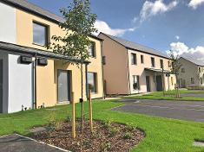 | Build better houses that people can afford to rent and heat
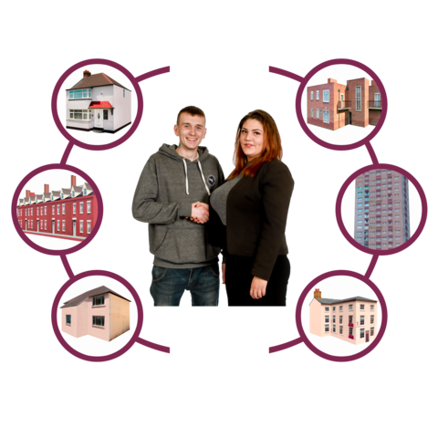 | Take actions to help stop people becoming homeless
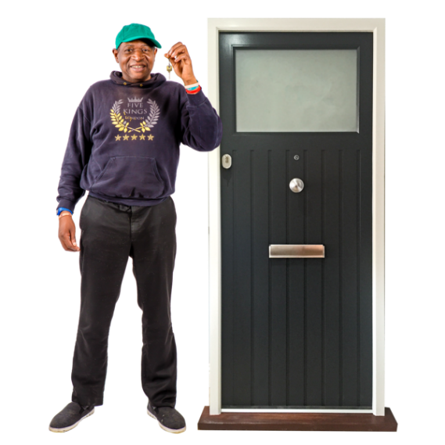 | Give people who need it help to stay in their own homes
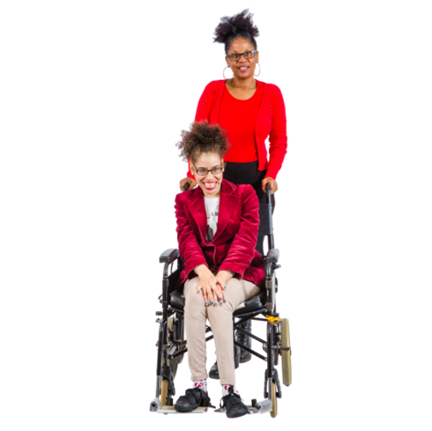 | Put together a plan for people who look after others

Health – Equality Objective 4

Health

This means

 | We will provide sport, health and chances for people to take part in the things they enjoy
 | For the mind as well as body
 | We will
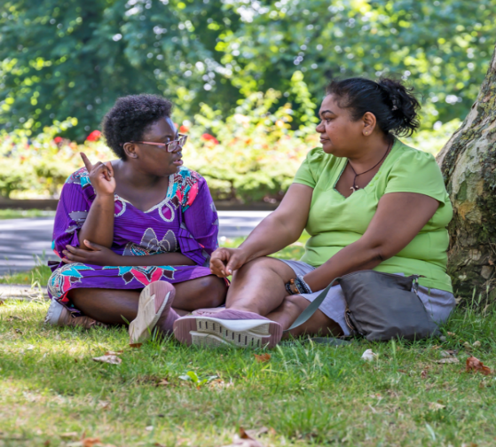 | Help people improve and use local green spaces
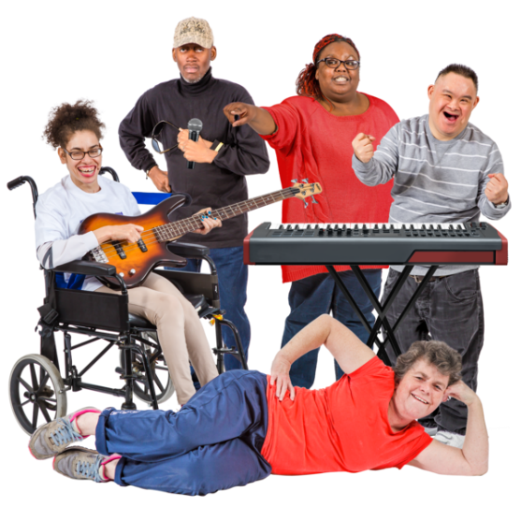 | Offer arts and craft activities that reflect and meet people’s different needs
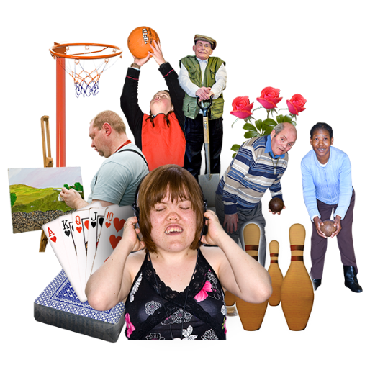 | Make sure healthy activities are affordable for everyone
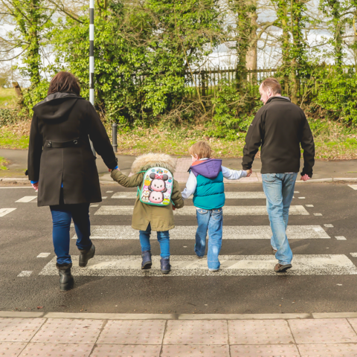 | Make pavements, roads, transport and buildings easier to use
Fairness Dignity and Respect - Equality Objective 5

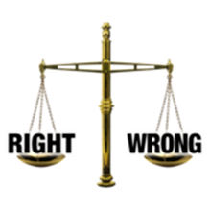 | Fairness, Dignity and Respect  This means
 | We will work to make sure people’s rights are respected
 | We want people to feel safe from harm
 | We will
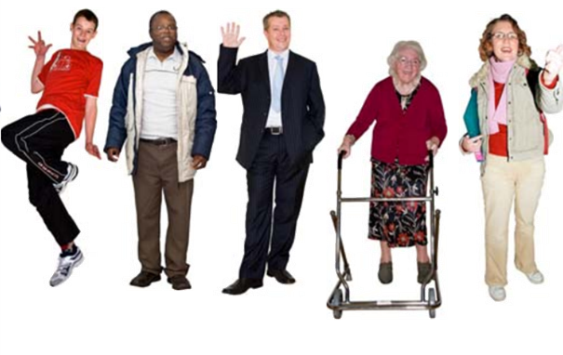 | Make sure we all celebrate being different and feel good about who we are
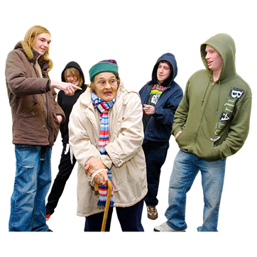 | Help people understand and stop hate crime and discrimination
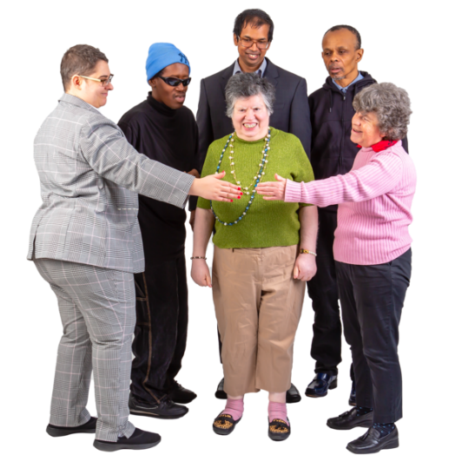 | Look out for people who need extra help to keep them safe
Participation - Equality Objective 6

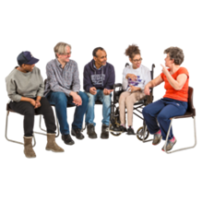 | Participation  This means
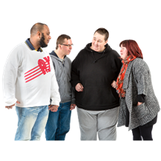 | We will improve how we talk to communities
 | We will involve people in things that are important to them
 | We will
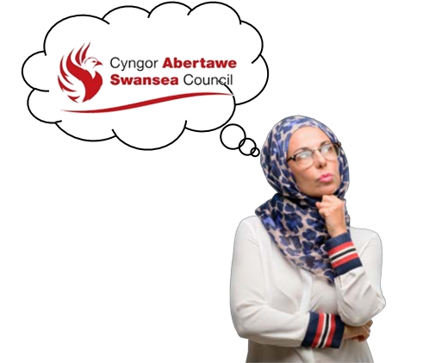 | Make it easier for everyone to say what they think about Council services
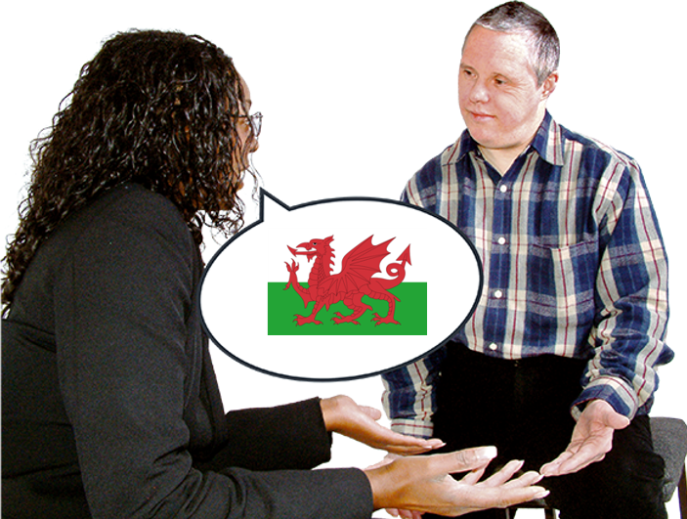 | Offer our staff Welsh language training
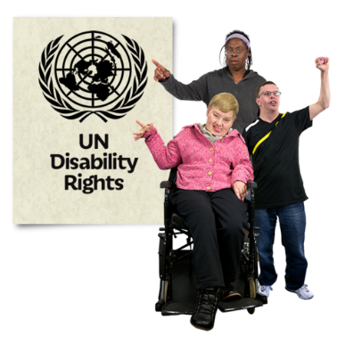 | Look at becoming a Human Rights City where lots of rights are understood and respected
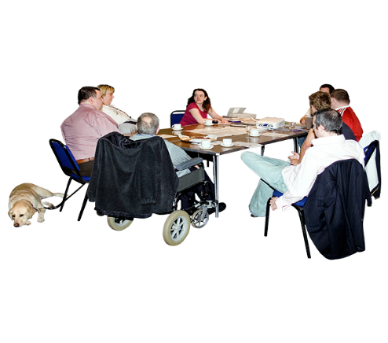 | Find out how people’s ideas can improve council services by working with people.  Ask what they think and  involve them in decisions about them

How to find out more or ask for another format

Call us on
01792 636732
Email us at
accesstoservices@
swansea.gov.uk
Thank you to everyone who helped with this Plan

West Glamorgan People First,
Your Voice Advocacy

