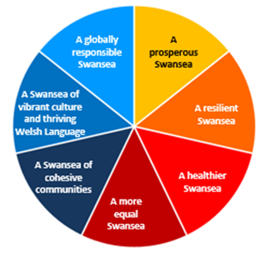 

**Swansea Public Services Board**

**Local Well-being Plan**

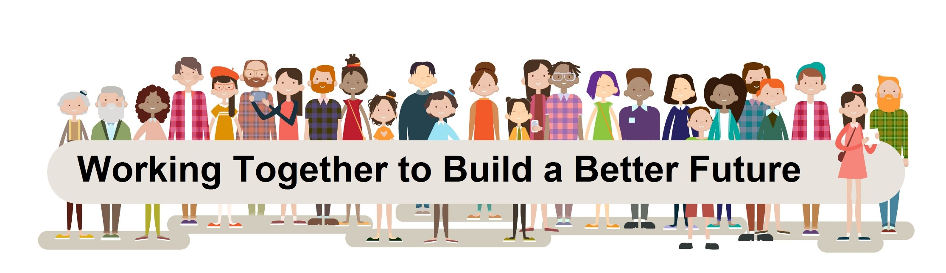

Contents

Message from the Swansea Public Services Board Page 03

Wales is doing things differently Page 04

Swansea is also doing things differently Page 05

Early years Page 07

Live well, age well Page 11

Working with nature Page 16

Strong communities Page 20

Sharing for Swansea Page 24 Appendix I: Making the Connections Page 26

Appendix II: Swansea Public Services Board Page 27

Appendix III: How the plan has developed Page 28

Glossary

Message from the Swansea Public Services Board

In Swansea, we believe in the rights of every person. Through this plan, our vision is to work together to make Swansea a place which is prosperous, where our natural environment is appreciated and maintained and where every person can have the best start in life, get a good job, live well, age well and have every opportunity to be healthy, happy, safe and the best they can be.

In 2016, the Public Services Board (PSB) started a conversation about well-being in Swansea. We carried out an Assessment of Local Well-being to understand what matters most to communities. The Assessment told us that for many reasons Swansea is a great place to live but that we need to work harder together to make sure everyone can live well, benefit from and be proud of Swansea.

Using information from the Assessment and by listening to people, we have identified four objectives and a cross-cutting action where working together will make the biggest difference to improve Swansea’s well-being.



**Strong Communities:**

**To build stronger communities with a sense of pride and belonging**



**Working with Nature:**

**To improve health, enhance biodiversity and reduce our carbon footprint**

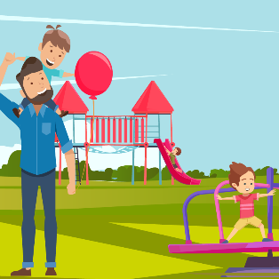

**Early Years:**

**To ensure that children have the best start in life to be the best they can be**



**Live Well, Age Well:**

**To make Swansea a great**

**place to live and age well**

**Cross Cutting Action - To work towards integrated public services in Swansea by sharing resources, assets and expertise**

This Plan sets out what needs to happen to reach each of our objectives. It then details the steps we will take together to make our objectives a reality.

|  |  |
| --- | --- |
| Seven well-being goals | |
| **Goal** | **Description of the Goal** |
| **A prosperous Wales** | An innovative, productive and low carbon society which recognises the limits of the global environment and therefore uses resources efficiently and proportionately (including action on climate change); and which develops a skilled and well-educated population in an economy which generates wealth and provides employment opportunities, allowing people to take advantage of the wealth generated through securing decent work. |
| **A resilient Wales** | A nation which maintains and enhances a biodiverse natural environment with healthy functioning ecosystems that support social, economic and ecological resilience and the capacity to adapt to change (for example climate change). |
| **A healthier Wales** | A society in which people’s physical and mental well-being is maximised and in which choices and behaviours that benefit future health are understood. |
| **A more equal Wales** | A society that enables people to fulfil their potential no matter what their background or circumstances (including their socio economic background and circumstances). |
| **A Wales of cohesive communities** | Attractive, viable, safe and well-connected communities. |
| **A Wales of vibrant culture and thriving Welsh language** | A society that promotes and protects culture, heritage and the Welsh language, and which encourages people to participate in the arts, and sports and recreation. |
| **A globally responsible Wales** | A nation which, when doing anything to improve the economic , social, environmental and cultural well-being of wales, takes account of whether doing such a thing may make a positive contribution to global well-being. |

Wales is doing things differently

The Well-being of Future Generations Act (Wales) 2015 asks the Public Services Boards and 44 Public Bodies to work together toward seven common well-being goals using five ways of working when making decisions.

Five ways of working



**The Long term:** The importance of balancing short-term needs with the need to safeguard the ability to also meet long-term needs.



**Prevention:**How to act to prevent problems occurring or getting worse may help public bodies meet their objectives.



**Integration:** Considering how public body’s well-being objectives may impact upon each of the well-being goals, on their other objectives, or on the objectives of other public bodies.



**Collaboration:** Acting in collaboration with any other person (or different parts of that body itself) that could help the body meet its well-being objectives.



**Involvement:** The importance of involving people with an interest in achieving the well-being goals, and ensuring that those people reflect the diversity of the area which the body services.

Swansea will also be doing things differently

Swansea is the second largest city in Wales, with a population (city and county) of 244,500. It is a population that is growing, and people are living longer. However, people’s life experiences are very different between our poorest and wealthiest communities. Membership of the European Healthy City movement brings a wider international perspective on ideas and possibilities to add to the Wellbeing outcomes of our citizens.

Swansea is an attractive place to work in and visit, with many people travelling to do both. It is one of the most ecologically rich counties in Wales, but there are threats to this resource and areas of poor environmental quality which need improving. Swansea has a high number of well-qualified people and is home to high numbers of students. Whilst the overall number of people who can speak Welsh is reducing, the number of young people under 16 years who can speak Welsh is increasing.

Looking to the future, Wales is a country that is changing and Swansea is changing too and will increasingly be made up of people from different backgrounds, as people choose to move into Swansea to live. The average number of people in a household is falling with more people living on their own than before. The sort of jobs people have are changing, with technology advances; increasing automation and changes in healthcare. In Swansea, we need to understand the challenges and opportunities these changes bring.

Swansea Bay City Region City Deal

The Swansea Bay City Region City Deal is £1.3 billion of public and private sector investment into the region creating around 10,000 jobs and will help deliver the [Swansea Bay City Region Economic Regeneration Strategy](https://www.swansea.gov.uk/swanseabaycityregioneconomicregenerationstrategy). It will improve economic well-being by creating good jobs and opportunities for the people and businesses of Swansea Bay.

The City Deal and activities of the [Swansea Economic Regeneration Partnership](https://www.swansea.gov.uk/swanseaeconomicregenerationpartnership) (SERP) will drive economic growth and contribute to the well-being goals by focusing on building a more prosperous, resilient and equal Swansea. The PSB sees the [City Deal](http://www.swanseabaycitydeal.wales/) as playing an important role in helping achieve the well-being objectives.

How did we get to the four objectives?

In 2016, the Public Services Board carried out an Assessment of Local Well-being for Swansea. The Assessment was based on six outcomes which represented the kind of place we would like Swansea to be. A place where:

* children have a good start in life
* people learn successfully
* young people and adults have good jobs
* people have a decent standard of living
* people are healthy, safe and independent
* people have good places to live, work and visit.

During Summer 2017, the PSB Partners, local voluntary and community organisations, and citizens discussed what is important for a future Swansea. These conversations were informed by the Assessment of Local Well-being, the Welsh Government Future Trends Report, people’s experience and expert participants. Ten themes for action were identified, the areas where there was the biggest opportunity to work together became our objectives.

|  |  |  |
| --- | --- | --- |
| **Themes identified via involvement** | **Analysis of fit with opportunities for collective action by PSB** | **Interconnected objectives and themes in the Local Well-being Plan** |
| Early Years  Ageing Well | **Objective: Early Years** - To ensure that children have the best start in life to be the best they can be. |
| Climate Change/Carbon Reduction  Biodiversity | **Objective: Live Well, Age Well** - To make Swansea a great place to live and age well. |
| Pride  Community Cohesion | **Objective: Working with Nature** - To improve health, enhance biodiversity and reduce our carbon footprint. |
| Social Capital/ Behaviour Change  Joint working | **Objective: Strong Communities** - To empower communities promoting pride and belonging.  **Cross cutting action –** Sharing for Swansea |
| Housing | *Housing is a key theme integrated within the objectives* |
| City Deal & Infrastructure | *The economy is a key theme within Strong Communities and via the City Deal and* [*Swansea Bay City Region Economic Regeneration Strategy*](https://www.swansea.gov.uk/swanseabaycityregioneconomicregenerationstrategy)*.* |

**Well-being Objective One**

Children have the best start in life to be the best that they can be when…

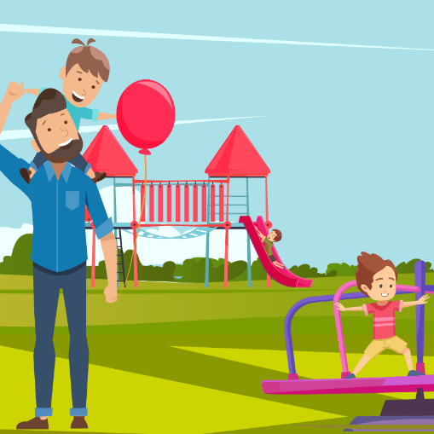

All children develop to their full potential

Parents and families are well prepared for birth and early childhood

Children are safe from harm and are supported at the earliest opportunity

Support services are high quality and well integrated

If children have the best start in life they are likely to be healthier, more likely to be better learners and less likely to experience deprivation as adults. Positive Early Years experiences lead to a greater likelihood of having a good job and a better standard of living, and of being more able to look after the environment and contribute to safe and prosperous communities (for more information, please see the Marmot Review).

Giving children the best start in life falls into the following three categories in Swansea:

1. Promoting important messages and information to all.
2. Enhancing universal Early Yearsservices through the availability of additional early intervention provision for expectant parents and young children to ensure strong foundations are in place for their future development.
3. Adding value to universal and early intervention services through the engagement and involvement of wider services and organisations to promote, signpost, co-plan and deliver community based support and activities.

**Using evidence from the Assessment of Local Well-being this diagram identifies what is needed to ensure children have the best start in life to be the best they can be:**

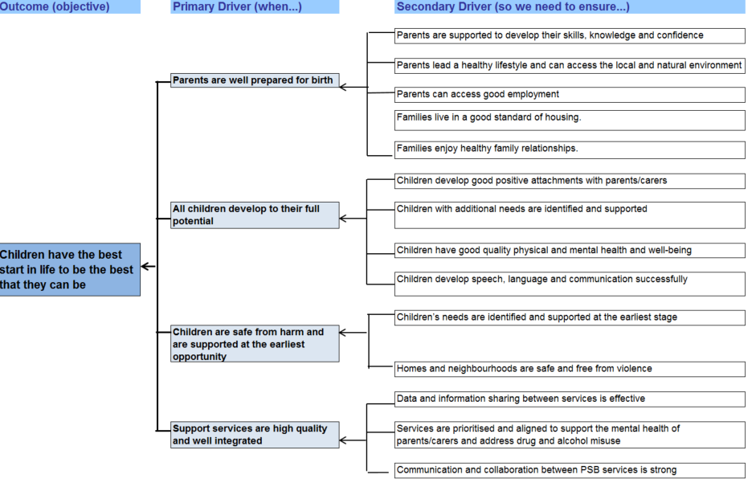

**Our Objective by 2040: To ensure that children in Swansea have the best start in life to be the best they can be. The Steps we will take towards this will be:**

|  |  |  |  |
| --- | --- | --- | --- |
| *The Steps to be taken* | *Short term ( < 3 years)* | *Medium term (4-9 years)* | *Long term (10-25 years)* |
| *To promote Swansea’s* [First 1000 Days](http://www.wales.nhs.uk/sitesplus/888/page/88523)  *Programme* | To support and join the Public Health Wales First 1000 days collaborative and develop an action plan to deliver the short term actions. | To review and implement medium term actions. | To use savings drawn from cost avoidance of the implementation of short and medium term steps to invest in the remaining actions. |
| *To ensure that parents are supported for birth and during early childhood* | To engage PSB workforces to make every contact count through promoting key messages and knowledge to families and adopting social prescribing at all levels. | To build on involvement elements of developing and embracing the messages by working together | To maintain the momentum into the long term. |
| *To more effectively integrate Early Years Services* | To explore opportunities to integrate Early Years services and learn from existing good practice in Swansea and beyond. To develop and test a Swansea model through pilots. | To evaluate and further embed a Swansea model to enhance closer multi-agency collaboration. | To fully implement the new Swansea Early Years model. |
| *To ensure that interventions are made earlier in life (and appropriately at later stages).* | To explore and pilot cross agency opportunities to deliver preventative services at an earlier stage. | To build on what works. | To maintain the momentum to ensure that the Adverse Childhood Experience (ACEs) cycle is reduced across the population. |
| *The Early Years Steering Group will be responsible for delivering the Steps. Specific leads will be identified as appropriate.* | | | |

**How we will maximise our contribution to well-being**

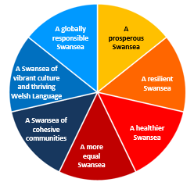

**✓**

**✓**

**✓**

**✓**

**Ensuring children have the best start in life will improve Swansea’s social and economic well-being. This objective will contribute to the well-being goals by focusing on building a healthier, more prosperous, equal and cohesive Swansea.**

We will use the five ways of working to enable the steps to be achieved

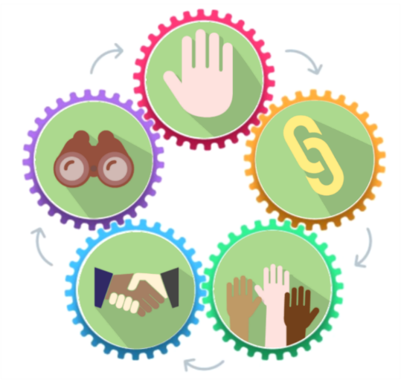

**Collaboration:** Share data, information, understanding and collaborate

**Integration:** Integrate resources and plan together

**Prevention:** Collective working to create conditions for children to flourish

**Involvement:** Taking a co-productive approach working with children, parents, carers and practitioners

**Long term:** Early interventions to maximise longer-term health and well-being

**Early Years**

**Well-being Objective Two**

People live and age well when…



They feel safe in their homes and community

They are as independent as possible and enjoy a good quality of life

They are valued, listened to and

are able to take control of their lives

They have the best possible level of health and well-being

Many people in Swansea are living longer. We know that there are big differences between our poorest and wealthiest communities. We want to support all people to age well, to be safe, healthy, independent and resilient in order to be able to reach their full potential. To achieve this we need to support people throughout their lives to access good quality jobs, have enough money to live on, have safe, good quality homes, and the ability to make decisions that enable them to flourish.

**Using evidence from the Assessment of Local Well-being this diagram identifies what is needed to ensure people live well and age well: The Steps we will take towards this will be:**

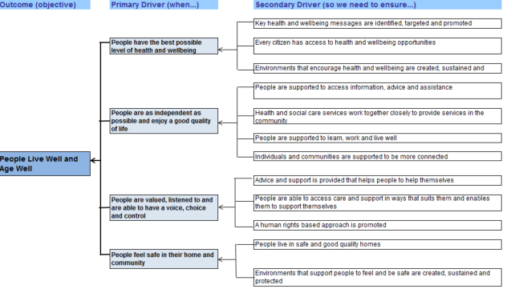

**Our Objective by 2040: To make Swansea a great place to live well and age well .The Steps we will take towards this will be:**

|  |  |  |  |
| --- | --- | --- | --- |
| Steps to be taken | Short term ( < 3 years) | Medium term (4 - 9 years) | Long term (10 – 25 years) |
| *Innovative approaches to health and social care* | **Maximise existing approaches and explore evidenced based approaches to health and social care, including new approaches to supporting end of life care. Co-produce an integrated and holistic Dementia Friendly Swansea action plan.** | **Embed innovative approaches alongside a highly skilled workforce that enables the delivery of quality care and family support in the community and better supports families to plan for end of life. Explore the value of emerging assistive technology in the home.** | **Ensure approaches are fully embedded across PSB enabling individuals and families with chronic or terminal health problems to have choice and access to quality and appropriate care and support in the community that meets their health and wellbeing needs.** |
| *Making every contact count* | **Support people to remain independent, safe and well in their own homes through the development of a ‘Making Every Contact Count’ model for Live Well Age Well to share key health, safety and wellbeing messages and signpost effectively. Roll out the Making Every Contact Count training and resources across PSB organisations.** | **Ensure Making Every Contact Count is embedded across the workforce as normal practise and continues to be developed to provide up to date and effective advice and signposting.** | |
| *Community based approaches* | **Explore a range of initiatives to tackle social isolation and build personal resilience across PSB and voluntary sector and develop an integrated plan on how we can tackle this as a partnership.** | **Deliver on short and medium term actions within the plan to ensure we have a range of initiatives to support people who are lonely or at risk of becoming lonely or isolated.** | **Ensure we have a range of preventative initiatives and support services available to all citizens in Swansea.** |
| *Innovative housing and technology* | **Explore innovative housing and assistive technology options for people with additional care needs to help people to remain independent at home** | **Develop technology responses through a wide range of public, private and third sector partners, offering personal choice and driving quality** | **Develop a range of housing options that suit individuals needs and enable people to remain independent in their own homes for as long as possible.** |
| *Culture change* | **Commence an intergenerational debate about what it means to live well and age well and develop a campaign based on the feedback that can be promoted across the life stages.** | **Respond to the campaign, developing approaches and services, which support continued independence and resilience. Continue to promote a live well age well campaign across the life stages.** | **Continue to drive a cultural change across partners and the community** |
|  | ***To be Led by the Ageing Well Steering Group with appropriate links to Western Bay*** | ***To be delivered by an extended partnership and include the wider community, third, private and public sectors to ensure full coverage of the actions in this objective*** | |

**How we will maximise our contribution to well-being**



**✓**

**✓**

**✓**

**✓**

**Supporting people to Live Well and Age Well will contribute to the well-being goals by focusing on building a healthier, more prosperous, more equal, more cohesive Swansea.**

We will use the five ways of working to enable the steps to be achieved.

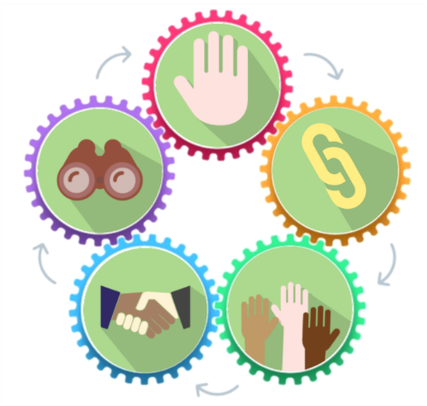

**Prevention**: Support people to build strength, independence and resilience throughout the life-course

**Integration:** More integrated front-line workforce giving people the right support at the right time

**Collaboration:** Sharing best practice, skills and experience and having collective strength in tacking key issues

**Involvement:** Developing robust and integrated involvement mechanisms

**Long term**: Early interventions to maximise longer term health and well-being

**Live well Age well**

**Well-being Objective Three**

Working with nature to…



Improve health and well-being

Reduce our carbon footprint

Maintain and enhance biodiversity

Improve our knowledge and understanding of our natural environment

A thriving natural environment provides many benefits to society, improving well-being and sustainable economic prosperity throughout the county. Swansea’s network of varied and attractive landscapes and wildlife habitats, including its coastline, uplands, woodlands, rivers and wetlands, and its urban parks and gardens, make it one of the greenest counties in the UK. We recognise, however, that some aspects of our natural environment are in decline and aren’t as resilient to change as we’d like them to be to deliver well-being. We need to stop exploiting nature and move to a situation where we’re working with nature for the benefit of all.

Working with nature can mean many things, from enhancing our green infrastructure in the city, to improving both mental and physical health, and our air and water quality, and increasing our renewable energy generation. In Swansea our aim is to work with nature to – improve health, maintain and enhance biodiversity, reduce our carbon footprint and improve our knowledge and understanding of our natural environment and implement nature-based solutions which have a meaningful impact on well-being.

**Using evidence from the Assessment of Local Well-being this diagram identifies what is needed to improve health, enhance biodiversity and reduce our carbon footprint:**

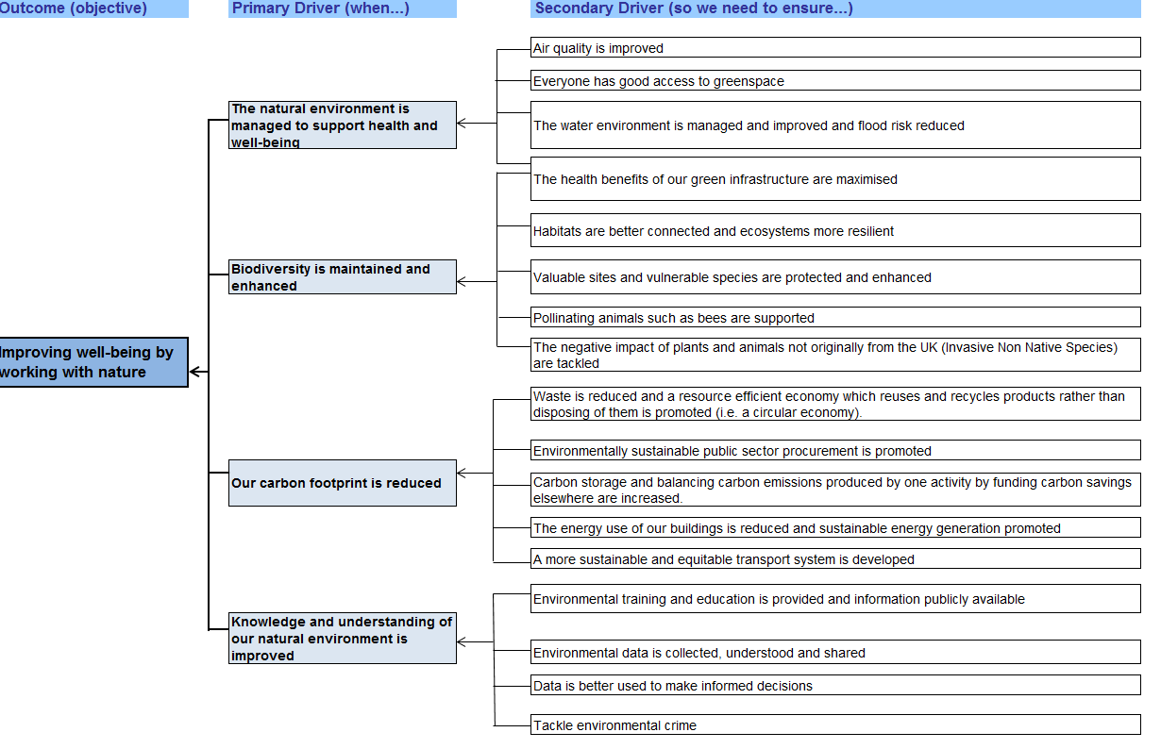

**Our Objective by 2040: To improve health, enhance biodiversity and reduce our carbon footprint. The Steps we will take towards this will be:**

|  |  |  |  |  |  |  |
| --- | --- | --- | --- | --- | --- | --- |
| Steps to be taken | | Short term ( < 3 years) | | Medium term (4 - 9 years) | | Long term (10 – 25 years) |
| *Green Infrastructure* | *Develop and implement a Green Infrastructure strategy for Swansea and work with communities to understand and engage with the opportunities for implementation.⁺* | | *PSB partners to engage with communities to implement the Green Infrastructure strategy for Swansea and act upon opportunities to implement interventions, maximising the health benefits these provide* | | *Nature to be at the heart of Swansea (such as by working towards a recognised status) by ensuring that Green Infrastructure is a key aspect of service delivery and communities are enabled to shape their place.* | |
| *Ecosystem Services*  *(Natural benefits)* | *Understand, and raise awareness of, the ecosystem services provided throughout the county. Reduce the risks and enhance opportunities around these* | | *Deliver nature-based solutions to enhance provision of ecosystem services throughout Swansea* | |
| *Carbon reduction and offsetting* | *Understand the risks posed by climate change to Swansea and the size of our carbon footprint. Identify and implement opportunities to reduce this.* | | *Explore opportunities for the use of PSB partners estate for local energy generation, community projects and supporting low carbon transport* | | *Partners collaboratively act to reduce carbon emissions through sharing assets and knowledge, in addition to joint working through local initiatives* | |
| *Improving knowledge and understanding* | *Undertake initiatives to increase awareness around environmental challenges (such as the decline in biodiversity) and opportunities (such as the availability of greenspace)* | | *Joint development and roll-out of wider environmental education and training packages across Swansea and within partner organisations* | | | |
|  | ***To be led by the working with Nature Task Group*** | | ***To be led by an expanded Working with Nature operational group including the wider community, all organisations and regional partners*** | | | |

*\*  This includes the opportunities for urban green infrastructure as well as accessing open greenspaces and the public sector estate.*

*⁺  The opportunities to reduce our carbon footprint will includes transport and waste (circular economy*).

**How we will maximise our contribution to well-being**



**✓**

**✓**

**✓**

**✓**

**✓**

**Working with nature will improve Swansea’s social, economic and environmental well-being. This objective will contribute to the well-being goals by focusing on building a healthier, more prosperous, resilient, more equal and globally responsible Swansea.**

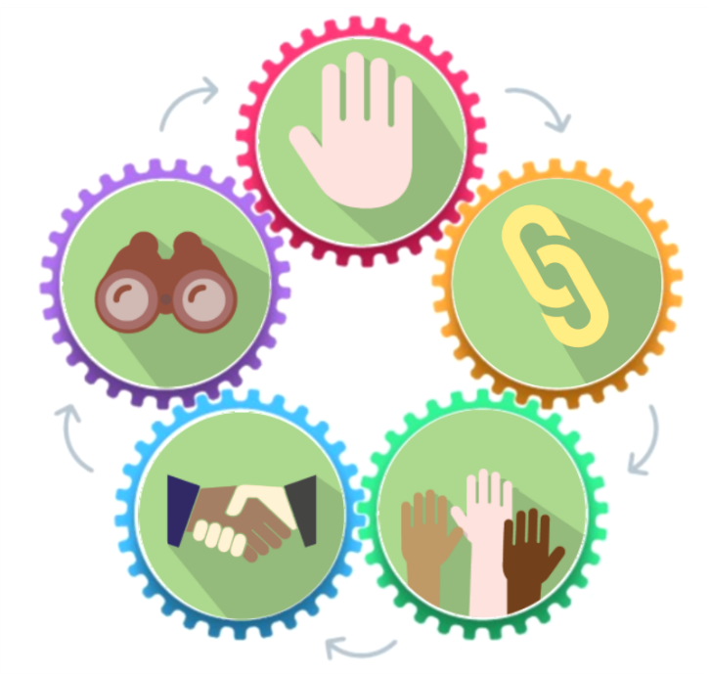The five ways of working are the ‘golden thread’ which will enable the steps to be achieved.

**Prevention:** Understand the causes of problems and work together with nature to prevent them

**Long term:** Understanding the long-term trends and working with nature to build a more resilient Swansea

**Collaboration**: Working together to maximise the benefits derived from nature

**Integration:** Ensuring we maximise the benefits of working with nature

**Involvement:** Working with communities to shape our green spaces

**Working with Nature**

**Well-being Objective Four**

## 

## Build stronger communities that…

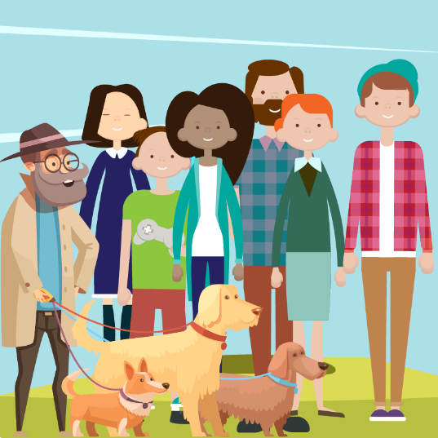

Have a sense of pride and belonging

Are more cohesive

Are prosperous

Enable individuals to trust each other

Support people to feel safe and be safe, confident

We want to make Swansea a vibrant, tolerant and welcoming place where everyone has equal access to opportunities and feels truly proud to live, work and play in Swansea. To achieve this we need to develop a place where people belong, feel safe, and where people’s backgrounds and circumstances are appreciate and valued.

Our communities are changing, we want to learn from each other and work together to build a better Swansea. We know that good relationships are an essential component of well-being. As communities change we will celebrate what they have in common and face challenges together; including tackling barriers to employment, training, educational attainment and inclusion.

To do this we know we need to work together to understand individual and community issues. We need to build trust between communities and local organisations, giving people a voice in decisions affecting their lives. It is important to support and work with vulnerable people and socially marginalised groups to foster inclusion.

**This diagram (based on evidence in the Assessment of Local Well-being) identifies what is needed to build strong communities:**

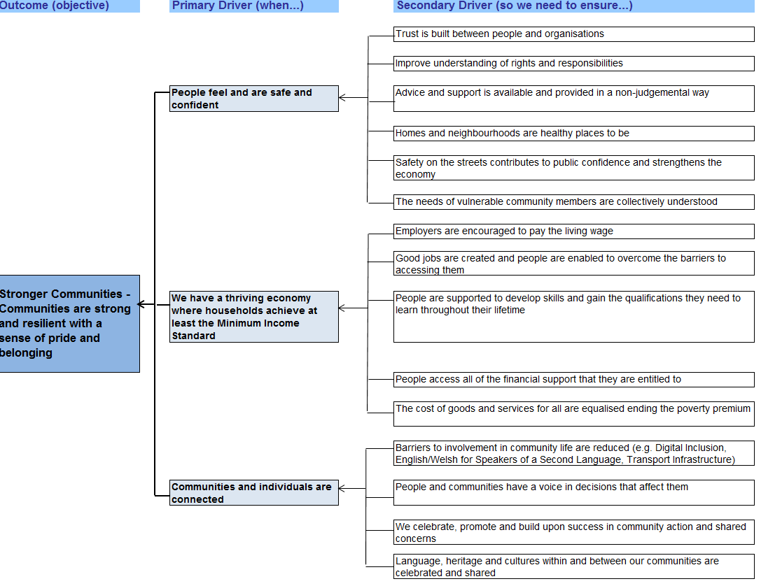



**Our Objective by 2040: To build strong communities with a sense of pride and belonging**

|  |  |  |  |
| --- | --- | --- | --- |
| *Steps to be taken* | *Short term ( < 3 years)* | *Medium term (4 – 9 years)* | *Long term (10 - 25 years)* |
| *People feel safe and confident in their communities* | We will work across PSB organisations to develop common understandings of asset-based approaches to developing community resilience, building on existing practice, leading to an action plan. | We will embed amongst all PSB partners, approaches that support individual, family and community resilience, leading to a whole organisation and whole public sector approach. | Actions to promote safe and confident communities are driven by the community (co-production). Trust will have increased between organisations and citizens taking a co-productive approach. |
| *Individuals and communities are connected and feel a sense of belonging* | We will develop a collective approach to promoting positive messages and opportunities and removing barriers to participation across Swansea.We will adopt the principles of an Intercultural City approach to promote the diversity of cultures and languages within Swansea, making use of the resources of one another to do so. | We will deliver collective action to remove barriers to participation including fear of difference, sharing resources regularly to do so. We will further embed our Intercultural City approach to promote Welsh language whilst also recognising and celebrating the other cultures, languages and communities in Swansea. | We will have fully embedded amongst all partners the principles of an Intercultural City approach, to enhance tolerance. |
| *Work towards a thriving economy in which households achieve at least the minimum income standard* | We will deliver a single public service approach to developing a thriving economy through the Swansea Bay City Region Economic Regeneration Strategy with alignment to the Council’s Tackling Poverty strategy, to ensure a thriving economy where the most disadvantaged people also can benefit. | We will fully embed the economic regeneration plans within all PSB partners and actions will be taken to enhance a social benefits approach. We will jointly design and implement local projects that support achievement of Minimum Income Standard. | We will deliver a single public service approach to developing a thriving economy and will change organisational processes and approaches to do this. |
| *On completion of the Swansea Local Well-being Plan, we will review governance arrangements to ensure effective delivery and oversight, identifying lead partners to be accountable for delivery. We will work on similar issues across wider geographical areas, to ensure the best use of resources.* | | | |

**How we will maximise our contribution to well-being**



**✓**

**✓**

**✓**

**✓**

**✓**

**✓**

**✓**

**By building strong communities we want to improve Swansea’s social, environmental, economic and cultural well-being. This objective will contribute to the well-being goals by focusing on building a more prosperous, equal, globally responsible, healthier, resilient and cohesive Swansea which celebrates our diverse and vibrant culture.**

**✓**



**✓**

We will use the five ways of working to enable the steps to be achieved



**Strong Communities**

**Prevention:** Work actively to celebrate difference and to ensure all residents feel they belong

**Integration:** Work to understand the impact we all have on each other

**Collaboration:** Listen to and trust each other

**Long term**: Work to understand the impacts of future trends on communities to help us prepare for a future Swansea we are all proud of

**Involvement:** Work together to ensure we build trust and maximise positive change in Swansea

**Sharing for Swansea** – Cross Cutting Action for Change

‘Sharing for Swansea’ is an approach which focuses on how Public Services Board Partners can work better together to achieve our objectives.

This means understanding how we can use our land, buildings, people skills, communications and knowledge more effectively together and making every contact count. This will enable us to best implement the Well-being of Future Generations (Wales) Act’s five ways of working.

The Ways of Working: Sharing for Swansea

**Our Objective by 2040: To work towards integrated public services in Swansea by sharing resources, assets and expertise, in order to develop a common language and make every contact count to maximise the contributions to Swansea’s well-being goals**

|  |  |  |  |
| --- | --- | --- | --- |
| *Steps to be taken* | *Short term ( < 3 years)* | *Medium term (4 – 9 years)* | *Long term (10 - 25 years)* |
| *Understanding one another’s priorities and context* | Complete programme of ‘walking in our shoes’ for all PSB core group partners  Explore joint approaches to responsible procurement | Strong understanding of one another’s business and seamless approach to service delivery, with increasing amounts of regional working | Organisations fully understand one another’s business and are able to act collectively on a regular basis |
| *Physical estates*  *(and/or assets)* | Take part in formal review of assets and/or services in pilot community hub areas and other initiatives. | Shared disposal of and investment in assets and consideration of impact of regional working realising maximum value of assets. | Shared use of physical assets as matter of course |
| *Coproduction and engagement* | Develop joint learning and standardise and improve existing processes | Single agreed process for coproduction and engagement | Citizens regularly engaging in policy and strategic discussions to influence delivery and enhance resilience |
| *Developing people and ways of working* | Coordinate a plan for areas of initial joint delivery  Develop a simple common language. | Identify roles and teams to increasingly work on a joint cross-organisational or cross-disciplinary basis  Single, multi-disciplinary teams for increasing elements of service delivery | Multi-disciplinary team are the Swansea way of working |
| *Developing Swansea as a Human Rights City* | Define what this means for Swansea and take initial action, building in existing partnership work around children’s rights | Development of a maturity model and an annual self-assessment process to evidence progress and benefits | Local citizens recognise and value the Human Rights City approach and outcomes from its adoption are visible and recognised |
| *On completion of the Swansea Well-being Plan, we will review governance arrangements to ensure effective delivery and oversight, identifying lead partners to be accountable for delivery.* | | | |

Appendix I - Making the Connections

Although each objective focuses on a specific priority as our diagrams show there are many areas of overlap. We believe it is critical that everyone contributes to all of the objectives not just the ones where our work makes the biggest impact. Even where the scope for action is relatively small, when we all address each objective collectively the impact can be game changing. The chart below maps the role of each objective in carrying out the steps.

|  |  |  |  |  |
| --- | --- | --- | --- | --- |
| Steps we will take | Early Years | Live Well,  Age Well | Working with  Nature | Stronger  Communities |
| *To promote Swansea’s First 1000 days Programme* | Lead | Support | Support | Support |
| *Parents are supported for birth and early childhood* | Lead | Support | Support | Support |
| *To more effectively integrate Early Years Services* | Lead | Consider | Consider | Consider |
| *To ensure that interventions are made earlier in life.* | Lead | Support | Consider | Support |
| *Innovative approaches to health and social care* | Lead | Lead | Support | Consider |
| *Making every contact count* | Lead | Lead | Consider | Support |
| *Local Area Co-ordination and social prescribing* | Lead | Lead | Consider | Support |
| *Innovative housing and technology* | Support | Lead | Consider | Support |
| *Green infrastructure* | Consider | Lead | Lead | Consider |
| *Ecosystem services* | Consider | Consider | Lead | Consider |
| *Climate change and carbon reduction* | Consider | Support | Lead | Support |
| *Improving knowledge and understanding* | Support | Consider | Lead | Support |
| *People feel safe and confident in their communities* | Support | Lead | Support | Lead |
| *Individuals and communities are connected and belong* | Support | Lead | Support | Lead |
| *A thriving economy - with the minimum income standard* | Support | Support | Support | Lead |
| *Physical estates* | Lead | Lead | Lead | Lead |
| *Coproduction and engagement* | Lead | Lead | Lead | Lead |
| *Staff training and development* | Lead | Lead | Lead | Lead |
| *Understanding one another’s priorities and context* | Lead | Lead | Lead | Lead |
| *Developing Swansea as a Human Rights City* | Lead | Lead | Support | Lead |

A detailed Action Plan will set out how we will implement the steps to achieve our objectives.

Appendix II Swansea Public Services Board

The Swansea Public Services Board is a partnership of organisations who work together to improve local services and includes:

Abertawe Bro Morgannwg University Health Board

Gower College Swansea

HM Prison and Probation Service

Job Centre Plus

Mid and West Wales Fire and Rescue Service

Natural Resources Wales

Public Health Wales

Regional Business Forum

Safer Swansea Partnership

Chief Constable of South Wales Police

South Wales Police and Crime Commissioner

Swansea Council

Swansea Economic Regeneration Partnership

Swansea Environmental Forum

Swansea Council for Voluntary Service

Swansea University

Wales Community Rehabilitation Company

Welsh Government

University of Wales Trinity St David

Community and Town Council representation

Every local council area in Wales is legally required to have a Public Services Board. This requirement is set out in the Well-being of Future Generations (Wales) Act 2015.

The Act asks Public Service Boards and 44 Public Bodies to work together toward seven common well-being goals and five ways of working to make sure that when making decisions they take into account:

* the impact they could have on people living their lives in Wales in the future
* how to work better with people and communities and each other
* how to prevent problems and take a more joined-up approach locally and regionally.

The Local Well-being Plan is designed to be about the collective action of the PSB Partnership. The PSB and Scrutiny will ensure that steps are in place to monitor that the Plan is achieving its objectives for Swansea and Wales.

Appendix III: How the plan has developed

Our involvement process started by asking citizens, children, staff, managers, leaders, service users and experts to imagine the Swansea they wanted to see in 2040 and identified key future trends that would impact this future. This long term approach underpins the development of our Local Well-being Plan.



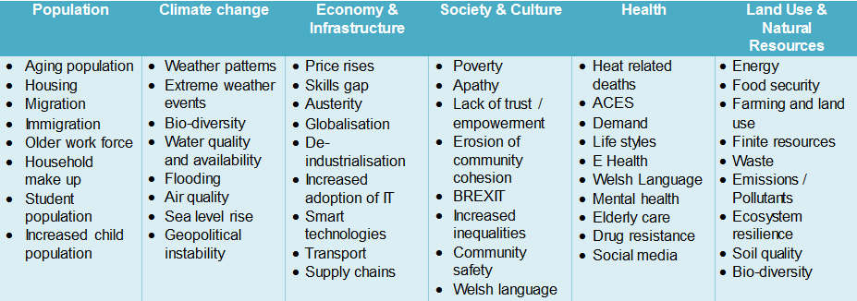



Our approach to involvement and engagement was based on the National Principles for Public Engagement and was designed to begin with a blank sheet and engage, re-engage and then formally consult with our stakeholders filtering down the collective priorities for action into objectives. This meant ideas could be refined into objectives with everybody’s buy in and voice being heard at every stage of the process.

Through its Assessment of Local Well-being the PSB has looked at what is working well to make Swansea a better place for people and where we can work together to make things better:

|  |  |
| --- | --- |
| **What is going well** | **What can be improved** |
| Many people are working together to improve children’s opportunity to have the best start in life. | We know that children’s start in life is not all the same and that the lifestyle choices a parent makes can impact on this, but these can be hard to change. We need to work together to change this. |
| School attendance and results at Year 10 and Year 11 are good and improving, and the local Higher and Further Education sector is strong with lots of good quality places to learn. | Evidence shows that there are links between where people live and how well they do in education. Generally, lower attendance rates are seen in areas of higher deprivation, and how well people do in post-16 education can vary. |
| The number of people in employment has risen over the long term. The productivity gaphas narrowed between Swansea and the UK. The City Deal and university expansion should generate economic activity and good jobs for people | Economic inactivity remains high. Swansea has a large public sector and therefore has fewer businesses than in similar-sized cities. More needs to be done to address barriers to employment and training. |
| Most people in Swansea have enough money to afford the essential things they need. Many people are working together to reduce how much people spend on essential items e.g. fuel, credit, that people who experience poverty often have to pay extra for. | There are large inequalities between our most and least deprived neighbourhoods in Swansea. For those in poverty well-being is low, with households – especially digitally excluded or without access to information – subject to the ‘poverty premium’. |
| Through the World Health Organisation *Healthy Cities Programme*, lots of partnership work is taking place around health with a particular focus on ageing well, Early Years and children, healthy urban environments and substance misuse. | Health and well-being improvement relies on changing our behaviours. This requires all of us to work together using our social capital. |
| Some aspects of the urban and natural environment, community resilience and sustainability are positive and improving; there is a high regard for Swansea’s cultural offer. | There is a continuing loss of biodiversity, natural green space, pockets of poor air and water quality, and significant deficiencies in housing and infrastructure – all of which have an impact on people’s well-being. |

To view the Assessment of Local Well-being, click here: [www.swansea.gov.uk/psbassessment](http://www.swansea.gov.uk/psbassessment)

As well as using information from the Assessment of Local Well-being, Swansea has taken the following things into consideration to make sure our Well-being Plan is the best it can be:

|  |  |  |  |
| --- | --- | --- | --- |
| **Future Trends Report 2017** | **Western Bay** | **What we have to do by law**  **(statutory duties)** | **The rights of all people** |
| This is a report written by the Welsh Government  It is a report that looks at trends in Wales and shows that:   * Life expectancy is increasing so the population is ageing. * Illnesses and conditions such as obesity, mental illness, dementia and diabetes are increasing. * Advances in technology will change the way we grow and prosper in Wales. * Political changes such as Brexit may affect what Wales looks like in the future. * Climate change will affect Wales. We will see pressures in terms of land use, what resources are available and the variety of plant and animals we see. | Swansea PSB works closely with Western Bay health and social care programme.  This regional partnership delivers across Neath Port Talbot, Bridgend and Swansea.  The development of both the Population Assessment and draft Area Plan have been informed and been informed by the work of Swansea PSB.  The Population Assessment can be found at found at [www.westernbaypopulationassessment.org](http://www.westernbaypopulationassessment.org)  The Area Plan can be seen at  [www.westernbay.org.uk/areaplan](http://www.westernbay.org.uk/areaplan) | The Act gives PSBs the choice to bring together a range of plans that set out what we have to do in specific areas. These plans are:   * The Crime and Disorder, Reduction of Offending and Substance Misuse Partnership Plan * Children and Young People’s Partnership Plan * The Western Bay Area Plan * The Part 1 Scheme ‘Local Primary Mental Health Support Services’ jointly agreed by the LHB and 3 local authorities under section 2 of the Mental Health Measure 2010 measure. * The Violence Against Women, Domestic Abuse and Sexual Violence Plan   The PSB agreed that to best work on these specific areas, there should be separate plans.  The Well-being Plan will support and add value to them. | All people have rights. These rights are set out in the United Nations Declaration of Human Rights.  We want to respect people’s rights and involve them in decisions that affect their lives and their well-being.  The PSB has developed an Involvement Plan to ensure that people are involved in decisions that affect their well-being.  Children have specific rights that are set out in the United Nations Convention on the Rights of the Child. In Wales, we have to show what we do to listen to children and young people. In Swansea, there is a clear and agreed commitment to supporting children to enjoy their rights. |

# Glossary

**biodiversity:** The variety of plants and animals on earth. It includes all species of plants and animals and the natural systems that support them.

**personal and community resilience:** how well an individual or community can respond positively to, withstand and recover from a difficult or negative situation.

**deprivation:** the lack of access to opportunities and resources which we might expect in our society to meet basic needs.

**deprived neighbourhoods:** a geographic area where there is a concentration of people experiencing deprivation.

**digitally excluded:** unequal access or skills to use information and communication technologies (ICTs).

**ecologically rich:**a geographical area that supports a wide range of plants and/or animals.

**ecosystems Services:** The benefits people get from ecosystems. These include food and water; regulating services such as flood and disease control; cultural services such as spiritual, recreational, and cultural benefits; and supporting natural processes that maintain the conditions for life on Earth.

**environmental quality:** the condition of the natural environment (land, air and water) and how it is affected by human activity i.e. pollution.

**green infrastructure:**good quality natural and manmade greenspace, including woodlands, wetlands, open and running water, river banks, parks and gardens, allotments, churchyards, recreational space, green roofs.

**Healthy Cities:** International learning network run by the World Health Organisation ‘requiring  local political buy in to deliver change’  to improve health for all. Swansea is the only designated ‘Healthy City’ in Wales at present.

**Intercultural Cities:** The Council of Europe’s Intercultural Cities programme supports cities in reviewing their policies through an intercultural lens and developing strategies to help them manage diversity positively and realise the diversity advantage.

**Making Every Contact Count:** An approach where employees of public services use every opportunity to deliver brief advice to improve health and wellbeing.

**Marmot Review**: an independent review into health inequalities in England published in 2010 ([www.ucl.ac.uk/marmotreview](http://www.ucl.ac.uk/marmotreview)). The Review, chaired by Professor Sir Michael Marmot, included a focus on Early Years interventions into health inequalities. The Marmot Report specifically suggested a need to:

* reduce inequalities in the early development of physical and emotional health and cognitive, linguistic and social skills
* ensure high quality maternity services, parenting programmes, childcare and Early Years education for all
* build resilience and well-being of all young children.

**Minimum Income Standard:** This identifies what the public think is an acceptable minimum standard of living each year. It includes, but is more than just, food, clothes and shelter. It is about having what you need in order to have the opportunities and choices necessary to participate in society.

**multi-disciplinary:** a number of experts, or people from different professions, working together.

**natural environment:** the natural (not man-made) surroundings in which a plant or animal lives.

**population:**the people who live in the City and County of Swansea.

**poverty premium:** the additionalamount which households on low incomes have to pay for the same essential goods and services;credit, fuel, food and transport. For example, fuel costs more per unit from a pre-payment meter than with an online Direct Debit discount. Also more fuel is used in households with poor insulation and inefficient appliances. Food costs more from small, local shops than larger ones which you can’t get to without a car.

**objectives:** or aims, are the goalsthe PSB are looking to achieve to improve people’s well-being in Swansea.

**social prescribing:** enables doctors and nurses to refer patients with social, emotional or practical needs to a range of local, non-clinical services, often provided by the voluntary and community sector

**urban environment:** man-made areas i.e. towns, urban environments.

**vulnerability:** A person is vulnerable if, as a result of a situation or circumstances, they are unable to take care of or protect themselves from harm or exploitation.

References

* [First 1000 Days](http://www.wales.nhs.uk/sitesplus/888/page/88523) programme - <http://www.wales.nhs.uk/sitesplus/888/page/88523>
* Swansea Bay City Deal - [www.swanseabaycitydeal.wales](http://www.swanseabaycitydeal.wales/)
* Swansea Economic Regeneration Strategy *-* [www.swansea.gov.uk/swanseabaycityregioneconomicregenerationstrategy](https://www.swansea.gov.uk/swanseabaycityregioneconomicregenerationstrategy)
* [Swansea Economic Regeneration Partnership](https://www.swansea.gov.uk/swanseaeconomicregenerationpartnership) - [www.swansea.gov.uk/swanseaeconomicregenerationpartnership](https://www.swansea.gov.uk/swanseaeconomicregenerationpartnership)
* Assessment of Local Well-being - [www.swansea.gov.uk/psbassessment](http://www.swansea.gov.uk/psbassessment)
* Population Assessment - [www.westernbaypopulationassessment.org](http://www.westernbaypopulationassessment.org)
* Local Area Plan - [www.westernbay.org.uk/areaplan](http://www.westernbay.org.uk/areaplan)
* The Marmot Review - [www.ucl.ac.uk/marmotreview](http://www.ucl.ac.uk/marmotreview)
* Police and Crime Plan - http://commissioner.south-wales.police.uk/en/us/police-crime-reduction-plan-2018-2021-and-executive-summary/