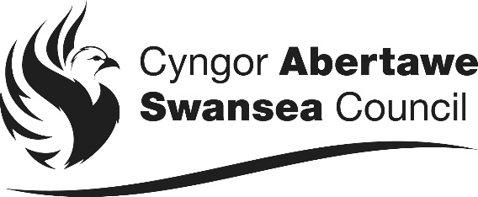 | HOUSING AND PUBLIC HEALTH  Civic Centre, Oystermouth Road, Swansea, SA1 3SN  www.swansea.gov.uk

 | Please ask for: |  |  | More Homes Team
 | Direct line: |  |  | 01792 635047
 | E-mail: | housing@swansea.gov.uk
 | Our Ref:
 | Your Ref:
 | Date: |  | June 2023

Dear Sir/Madam,

REFURBISHMENT OF THE TUDNO AND EMRYS ESTATE

This letter is to update you on the progress made so far regarding the refurbishment plans for the regeneration of the Tudno Place and Heol Emrys estate and reassure you that the Council is fully committed to making all necessary improvements to your home and estate.

As you may be aware, the Council has been working with the consultants Powell Dobson Architects to develop a masterplan to improve your area. This work was completed in October, and a consultation event took place on 20th October 2022 to share the design proposals with residents.

The enhanced refurbishment of the estate will include the following work:
- Internal improvements to include new kitchens and bathrooms, rewiring and new boilers where required. This will be the priority first phase of work.
- External works to the fabric of the buildings to improve energy efficiency and lower energy bills, through installing external wall insulation, new roofs with improved insulation, new windows and external doors.
- Landscaping throughout the estate to improve streets and communal spaces.
- Alterations to properties that may include forming new window or door openings where feasible.
- Moving the play area to a better, more overlooked location
- Building some new council housing on the unused open space on the estate, and improving the rest of the environment

The Council is in the process of appointing architectural design consultants to carry out the next stage of the detailed design work that will be needed to implement the changes.

The refurbishment proposals for the estate are significant and the scope of the work will mean that the project will be divided in phases over a number of years.

In the coming months you may see technical officers from the Council and our consultants undertaking a range of surveying tasks in preparation of future refurbishment work. We anticipate our in-house contractor, Building Services, will start the first phase of an internal improvements programme to some homes later this autumn. We will provide a more detailed plan of how all the works will be delivered and approximate timescales to undertake the work, after all refurbishment designs are competed.

Once the planning design work for refurbishing existing homes has been completed, the architectural consultants will produce a plan for the new properties to be built on the estate. The new build will be in the later phases of the scheme, as work to refurbish the existing homes will be given priority.

If you have any questions you can ring the More Homes Team on 01792 635047 or email housing@swansea.gov.uk

Going forward, we will ensure that we provide you with regular up-dates on the progress of scheme. You can expect a further update in around two months’ time. A dedicated webpage has also been set up to provide you with more information https://www.swansea.gov.uk/tudnoandemrys.

Yours sincerely,
Carol Morgan
Interim Head of Housing and Public Health
To receive this information in alternative format, or in Welsh please contact the above.

