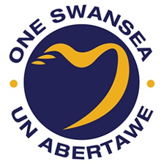
Swansea Public Services Board Local Well-being Plan 2023
Involvement and Consultation Response Report

1 Summary

Consultation on Swansea’s Local Well-being Plan undertaken between November 2022 and February 2023 forms part of a broader involvement process engaging a variety of stakeholders throughout the Plan’s development. An approach was adopted based on good practice including the National Principles for Public Engagement and National Participation Standards. While the Plan built on and links to work on the Assessment of Local Well-being, it is not constrained by the format or approach of this work. In order, to take a long-term approach and build on success to date the Plan updates the 2040 Objectives set out in the 2018 Local Well-being Plan.
To reach out to Swansea’s diverse population, the consultation would be delivered in the way each organisation felt most appropriate to connect with their service users, networks, and contacts, continuing the tone and nature of existing relationships. Engagement mechanisms used by partners ranged from workshops, drop ins, an online survey, and invitations for formal organisational responses.
All feedback was then analysed and collated into a matrix of over 250 key issues, actions and themes before being carefully considered. A table details the key issues raised and how the PSB has responded. Involvement is part of an ongoing process with feedback gathered via consultation informing the both action planning and implementation of the Plan

2 Background to involvement
2.1 Continuing the well-being conversation
Swansea PSB’s 2018 Local Well-being Plan was based on intensive engagement and foresighting focusing on a vision for Swansea in 2040. This context and long-term perspective formed the background and starting point for the development of Swansea’s 2023 Plan. Feedback from consultations in October/November 2021 and February/March 2022 included input from a wide diversity of experts, practitioners and lived experiences. Analysis strongly suggested the issues and changes identified in our 2022 Assessment of Local Well-being are broadly compatible with and in fact build on progress made to date towards the existing long term local well-being objectives.
As a result of this analysis and partner engagement, the Joint Committee proposed a review of the existing 2040 local well-being objectives, in order to continue work on our existing trajectory towards increasingly relevant long-term outcomes by 2040. This approach benefited from continuity, in that that having identified broadly the ‘what’ that the PSB want to achieve strategically, the PSB was instead able to focus on the development of action-based steps. This approach also enabled us to concentrate on ‘how’ we can work more effectively together, collaboratively developing new ways of working.
This approach enabled the PSB to focus on continuing rather than starting an entirely new conversation. This also meant we explicitly honoured the contribution already made by so many people to the long term 2040 direction set in 2018 while adapting the Plan to ensure it was fit for purpose given changes over the five years prior to 2023. This approach was endorsed at every level of initial organisational engagement via the PSB and later via public consultation.
2.2 Standards and Advice
Involvement is the key principle underpinning the development of Swansea Public Services Board’s Local Well-being Plan. The development process involved citizens, service users, staff, and experts as well as leaders throughout rather than at the end of the process. Swansea PSB’s formal commitments to the National Principles of Public Engagement, Children’s Participation Standards and United Nations Convention on the Rights of the Child underpin the involvement process.
The process was also informed by ongoing peer support workshops facilitated by the Co-production Network for Wales and a series of workshops on key issues including poverty, communities, climate change and health inequalities run by Welsh Government and subject experts such as the Welsh Centre for Public Policy.
Throughout the process, Swansea PSB worked closely with the Regional Partnership Board and Neath Port Talbot PSB coordinator holding regular meetings to ensure effective integration and collaboration. A relationship was maintained throughout the process with the Local Development Plan team to ensure alignment.
A close working relationship with the Office of Future Generations Commissioner over a 14-week period resulted in valuable advice which helped guide the development of the Plan both prior to and during consultation.
Leadership was provided by the Joint Committee and Statutory Member Leads for each objective. Operational support was provided by a Planning Group with social, economic, environmental, and cultural expertise derived from across PSB partner organisations.

2.3 The environment
The statutory timing of Local Well-being Plan development unfortunately clashed with engagement taking place on a wide variety of strategic topics across organisations in an environment where consultation fatigue was anecdotally reported as high and a cautious approach to in person involvement was still in place. This environment has generally resulted in less public engagement with surveys and formal consultation despite as much if not more outreach activity as in previous years. Public services both locally and nationally are reflecting on how changes to the ways we involve people in strategic planning may improve public participation levels moving forward.

3. The Involvement Strategy
An overview of Swansea PSB Involvement Strategy is set out in the diagram below.
The process of refining Swansea PSB’s local well-being objectives and development of the steps
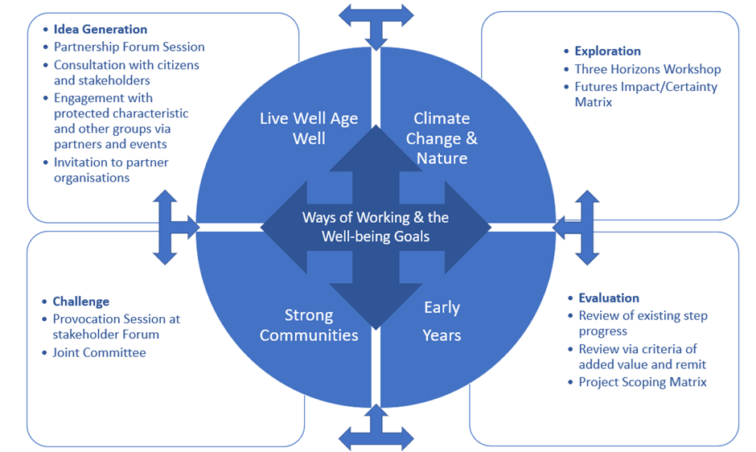

During an initial Challenge Phase, the Joint Committee examined evidence set out in the Assessment of Local Well-being Plan and set draft objectives which were challenged and refined following a ‘provocation session’ led by Natural Resources Wales at Partnership Forum (Full details are provided in Appendix B).
Moving into the Idea Generation Phase, the Partnership Forum also focused on the identification of ideas for collaborative action (Full details are provided in Appendix B). This process was continued throughout the Consultation period with presentations being made to groups such as the Ageing Well Steering Group.
The Exploration Phase looked at what long term trends might mean for our vision and how we could employ actions that helped bridge the gap between the Swansea we want of the future and current best practice examples today. A 3 Horizons workshop was organised in parallel with Neath Port Talbot PSB and was facilitated by NRW (Full details are detailed in Appendix C).
Key issues arising from the Assessment of Local Well-being were evaluated using the Welsh Government Futures Certainty/Impact Matrix by operational leads and considered by the Joint Committee. However this tool was found to be of limited application at the broad level of issues identified as key to the Assessment. This was perhaps because in order to be identified in a grid of key issues (later included in the Appendix of the Local Well-being Plan) they all shared a level of importance and relative certainty of outcome. It was however agreed that the tool might be more effectively used in future at an earlier stage, breaking issues down into smaller segments for consideration.
The Final Evaluation Phase took the process through to the completion of the Plan and into applying it in action planning. This involved reviewing the steps of the last cycle, applying criteria in terms of success factors identified in lessons learnt from the last cycle and using the lens of the Project Scoping Matrix to consider the appropriateness of the steps (This is detailed in Appendix D).
In addition, during the consultation period, a Driver Diagram workshop for the editorial team was hosted by Swansea Bay University Health Board to ensure the Assessment of Local Well-being was reflected in updated diagrams and an additional Summary Report of the Assessment published to improve accessibility of the Report.
The aims of the Involvement Strategy were;
- To build on existing engagement via the Assessment of Well-being engagement by focusing on updating the 2040 objectives, developing a small number of meaningful steps and annual action plans.
- To use simple language and visuals to communicate the draft 2040 objectives to a diversity of the community for updating and to confirm this approach was the right one.
- To maximise electronic feedback where possible but also ensure wider voices offline have an opportunity to fully contribute.
- To encourage as many people that reflect the diversity of our community to take part as possible especially using contacts within partner organisations and piggybacking on existing events and meetings particularly to reach people with protected characteristics or who from excluded or under-represented groups.

4. The Consultation
4.1 Methodology
Statutory Consultation took place between November 21 2022 and February 13, 2023. This consultation period again involved citizens, the community and voluntary sector, service users, staff and leaders of the Public Services Boards partners, in addition to wider stakeholders and resulted in significant changes to the Plan.
To reach out to Swansea’s diverse population, it was agreed that partners would each connect with their service users, contacts, networks, stakeholders and staff in the most meaningful way for both their organisation and each audience. By piggybacking on existing organisational engagement mechanisms, the consultation avoided ‘consultation fatigue’ and was able to connect with people in the most appropriate ways.

4.2 Consultation Materials
As the administrating organisation, Swansea Council also developed and hosted an online questionnaire for the use of all members, social media tweets and posts, posters, PowerPoint slides and a response template which partners could use, adapt or ignore when connecting with their service users in the best way that continued the tone and nature of existing conversations.
In addition, materials were made available to support partners connect with the diversity of Swansea’s population. This included a plain text format, Welsh language version and in addition, an EasyRead version was commissioned from West Glamorgan People First: Your Voice Advocacy.

4.3 Key Messages
Consistent key messaging were used across all consultation mechanisms
Have Your Say – Swansea Public Services Board Local Well-being Plan 2023 Continuing the Conversation
In 2018, people in Swansea identified what mattered to them most about improving well-being by 2040. Despite the pandemic, research as part of an Assessment of Local Well-being suggests these long term objectives remain broadly relevant with a little updating. We need your help to identify the next steps, that Swansea PSB partners can take together to improve Swansea’s well-being over the next five years (The Online Questionnaire is detailed in Appendix E).

5. Consultees
In order to ensure that the Public Services Board discharged its statutory duties, the Local Authority publicised the draft Local Well Being Plan and consultation process with the following groups and individuals;

- the Future Generations Commissioner,
- the Children’s Commissioner, the Welsh Language Commissioner, the Equalities Commissioner,
- the Board’s statutory members and its invited participants that form the Joint Committee; Swansea Council, Swansea Bay University Health Board, Mid and West Wales Fire and Rescue Service, Natural Resources Wales, Welsh Government, Swansea Council for Voluntary Services, The Chief Constable of South Wales Police, The South Wales Police and Crime Commissioner, Probation Service Representative, and Regional Housing Forum representing Registered Social Landlords,
- the Board’s other partners input primarily via the Partnership Forum and Objective Delivery Groups. (Such as Swansea Environmental Forum, the Safer Swansea Partnership and Swansea Learning Partnership; Community and Town Councils); DVLA , Gower College, the University of Wales Trinity St David Swansea, Swansea University, Arts Council of Wales Regional Business Forum, Swansea Economic Regeneration Partnership, etc, . The Partnership Forum is also open to any organisation across the public, private and third sector in Swansea.
- the Local Authority's Scrutiny Programme Committee
- Swansea BID (City Centre), South Wales Chamber of Commerce, Regeneration Swansea, Businesses via the Business Directory Newsletter
- Trade Unions: Unison, Unite and GMB;
- the general public;
- Rural Development Partnership network
- Schools and school governors, Families Network
- Welsh language speakers via Welsh Language Standards Officer contacts and people with protected characteristics via Access to Services, Interfaith Forum City of Sanctuary and Community Cohesion network.
- Neurodiverse and people with additional learning needs
- Community centre networks, neighbourhood officers, Local Area Coordinators
- Cultural practitioners
- Community and Town Councillors, Swansea Council Councillors, AMs and MPs,
- Local Development Plan and Regional Partnership Board officers
- Voluntary and community groups and special interest/issue forums and networks (through the PSB partners’ existing mechanisms for consulting with seldom heard from groups);

In addition, partners worked directly with schools, childcare settings, schools, youth groups, local businesses, chaplains and dignitaries, Swansea Carers Centre, via local cluster networks, and contacts in the third sector, and community groups. This included seldom heard from groups such as people with mental health issues and carers. The disability and equality reference groups of various organisations were also engaged such as Aging Well Steering Group and Swansea LGBTQ+ Network. Welsh speakers were engaged via Menter Iaith and the organisational staff Champion’s network.

6. Tool and techniques
Engagement mechanisms employed included;
- An online survey (including hard copies for people who were unable to access the survey on-line and screen reader friendly version).
- Drop ins for members of the public held at Clydach Library, Central Library and Swansea Museum.
- Presentations and discussions with existing groups, networks and forums.
- A Partnership Forum with stakeholders which focused on discussing the plan.
- 1 to 1 face to face meetings / discussions with individual stakeholders.
- Briefings with managers, teams and staff groups.
- Raising awareness of the plan and the consultation using Social Media, including Facebook and Twitter, syndicated via partner accounts.
- Raising awareness of the plan via organisational websites and publications including the South Wales Evening Post.
- A presentation by Swansea PSB’s Chair at Community and Town Council Forum to respond to the consultation and engage with their constituents on key issues included within the Draft Local Well-being Plan.
- Staff facing intranets and public facing internet sites of partners;
- Use of communications teams contacts in key partners internal and external marketing
- Plan on a page A3 Poster.
- Use of QR Codes at events, to engage those who prefer digital engagement in their own time.
- Response template for groups and customisable presentation to share the ask.

Examples of tools and techniques employed
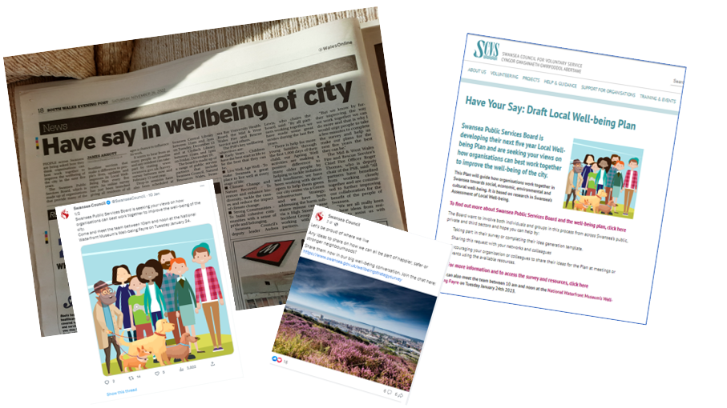

7. Survey Responses
- responses were received in total (including one paper-based response).

7.1 Views on the Plan and Local Well-being Objectives

- 68% of respondents had read the well-being Plan, their views are detailed in the chart below.

- Approximately 69% of respondents agreed it was an appropriate length. 80% agreed that the Plan is well laid out, 79% agreed it is easy to understand and 78% agreed it is easy to read.

Respondents’ responses to the draft Local Well-being Objectives

Agreement with the choice of Local Well-being Objectives was high, 89% of respondents agreed with Strong Communities, 90% agreed with Climate Change and Nature Recovery, 96% agreed with Live well, age well and 98% agreed with Early Years.
Around a third of comments agreed with the Plan or referenced elements already central to it such as sustainability, interconnectedness, huge, consistency, all good things, people should take pride in area.
Around a third of comments were considered but not appropriate, not in scope or already explored – for example including an objective focusing on economy, Early Years as part of Live Well Age Well, and incorporating Livewell age well in Strong Communities.
The remainder were largely action related including comments such as – no extra costs with climate change, grow food, sensible balanced land use, support local traders, and no anti-social behaviour.
Feedback for the PSB included the comment, action does not match rhetoric
Respondents’ responses to the draft steps

- All the steps have between almost 78% and 92% agreement indicating no major issues and broad agreement.
- Approximately a third of responses were concerned with specific actions for example, information is needed on what is going on in Swansea, public transport, alternative formats should be offered not requested, city centre should be a place to come together, etc.
- Issues raised – included the use of jargon, technical language and not being sure what terms like equitable transition, cultural offer mean?
- Steps need to be broken down into smart goals, further detail on short, medium and long term, put steps at the start of plan.
7.2. Collation and analysis of action related ideas or comments
Swansea’s consultation process generated hundreds of comments all of which were recorded and analysed. Actions, comments, and common issues were then collated into a matrix. Feedback collected from the survey, workshops and drop ins were then analysed centrally and collated detailing common themes, key issues, and specific actions. This classified the feedback into three categories for ease of analysis.
- 80% - Action Planning Phase related (operational level ideas which fit into existing steps and objectives) These covered all four objectives, all five action-based steps directly and governance, performance, and data development more indirectly.
- 5% - Comments which were already within the Plan or which were not relevant or appropriate etc. (e.g. not in line with statute, regulation or PSB shared values/commitments) so on which no further action was required.
- 15%- Reflected the Plan’s ways of working in detail best considered by the Joint Committee.

This input was reviewed by a planning group and further amendments taken forward and made to the Plan by Objective leads. The resultant changes were reviewed by PSB Joint Committee, and the final version of the Plan agreed.

Examples of actions include;
- Early years - Neurodiversity screening all under 18s, add educational information to timelines to health information for parents, early help for families preventing crisis
- Live well, age well - embed social model of disability, more well-being events, play areas, four day week, and centrally located services
- Climate Change and Nature Recovery – More green infrastrcuture, litter/waste, sustainable transport, Bwyd Abertawe, 15 min cities, Kilvey, pesticides, dog control
- Strong Communities – community transport, co-housing, support for climate change positive start up, singing on prescription, lidos, local artist graffiti.
- Cross cutting issues raised included information sharing, offline and wider engagement using innovative methods, listening to people, web communications and newsletters, coproduction.

7.3 Characteristics of Respondents
- Respondents identified themselves as 56% members of public, 35% Council staff, 5% third sector, and 1% private sector.
- 60% of respondents identified as female, 26% male,1% self-described, and 13% preferred not to say.
- 85% of respondents identified as same gender at birth with 15% preferring not to say.
- In terms of national identity, 42% identified as British, 42% Welsh, 10% preferred not to say, 2% as non-British 2%, and 4% Scottish or English. No respondents identified as refugee/ asylum seekers.
- In terms of Ethnicity 81% of respondents identified as white, 16% prefer not to say, 1% were mixed white & Asian, and 1% Arab.
- 42% of Respondents identified as having no religion, 34% as Christian, 21% preferred not to say, 1% were Buddhist, 1% muslim, and 1% identified as other.
- In relation to sexual orientation- 75% of respondents identified as heterosexual, 20% preferred not to say, 3% were bisexual, and 2% gay/ lesbian.
- Conditions or illnesses expected to last over 12 months+ impacted 21% of respondents, with 59% not being impacted and 20% preferring not to say.
- 13% of respondents said that their conditions or illnesses impacted carrying out day to day activities, 23% preferred not to say while 64% were not affected.
- The pie chart below demonstrates a good variety of ages were represented although no over 85s and few under 25’s participated in the survey. 12.6% preferred not to say their age.

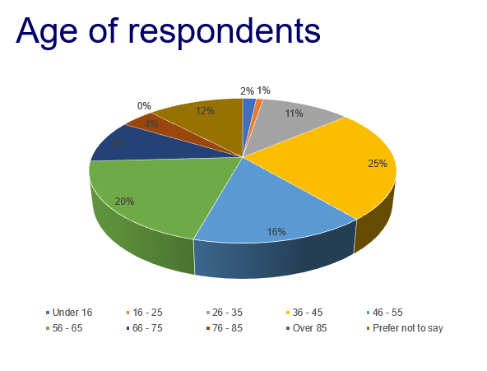

- No surveys were completed in Welsh although of those who stated their day-to-day language, 88% used English, 11% Welsh and 1% other. Reported Welsh language abilities are summarised in the graph below.
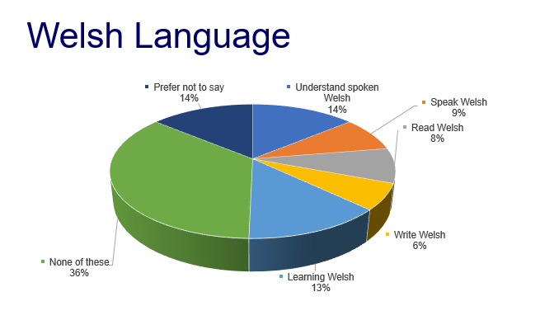

8. Organisational and Facilitated Responses
8.1 Children’s’ Rights Day
Swansea PSB hosted an activity stall as part of Children’s Rights Day celebration held at the Waterfront Museum. Attendees included children from 25 primary & 10 secondaries. In total, 88 ideas in words and pictures were collected about how organisations can work together to make life better in Swansea. All were action based other than one communications based idea. The word cloud below sets out some key words raised.

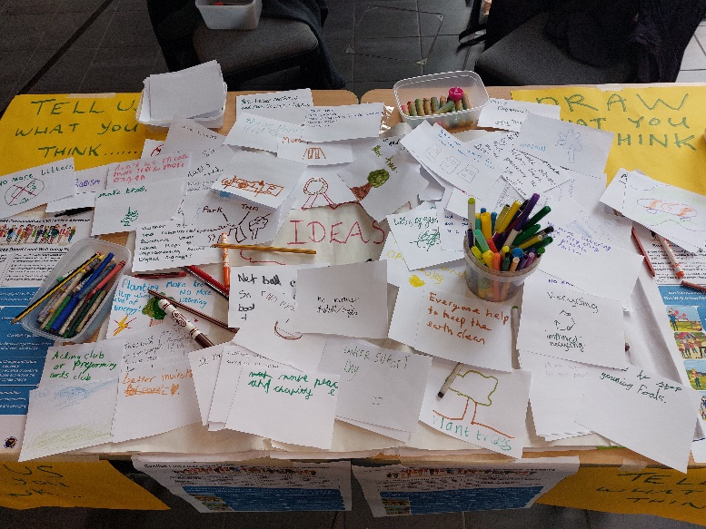
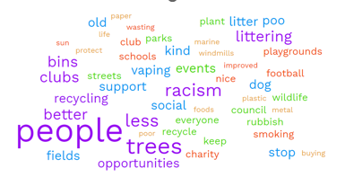

8.2 Waterfront Museum Well-being Fayre

This event took place on 23 January 2023. All attendees who discussed the local well-being objectives welcomed draft objectives. All ideas collected were action based. They included more toilets, fitness activities, shared use of ex-field hospitals, intergenerational sites for care and nurseries, better bus services, dog poo bins, and park and rides.

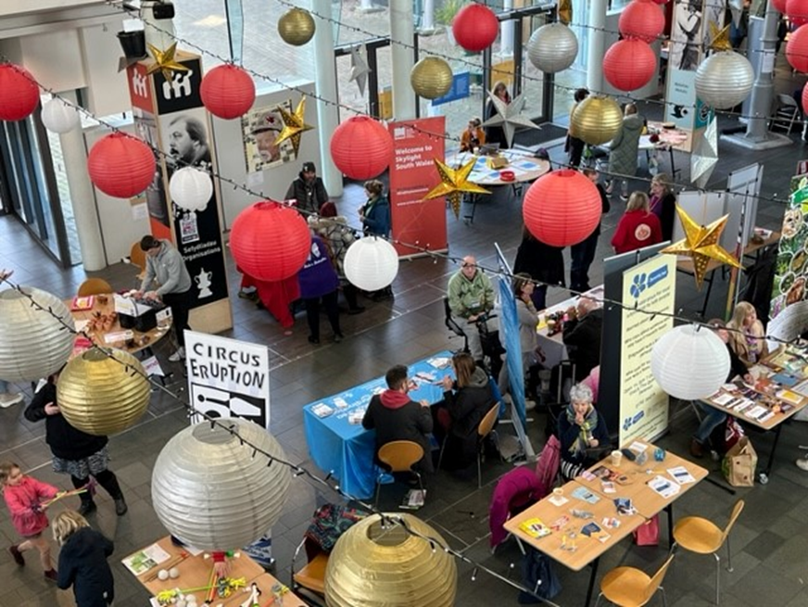

8.3 GP Cluster Engagement Event

This joint online presentation and discussion held with Neath Port Talbot PSB identified lots of alignment with emerging cluster action plans. Ideas for action included digital literacy and ensuring accessible services, homelessness, community transport in rural areas, neurodiversity assessment timescales (3 years), Inhaler recycling, well-being activities to combat poor mental health, early years awareness of sight, audio, immunisation need and Health of Homelessness and Vulnerable Groups escalation pathway potential?

8.4 Additional Learning Needs and Neurodiversity

An Easy Read version of the Survey circulated by email and social media as well as in paper format attracted 15 responses as well as input collected at three workshop sessions run by West Glamorgan People First: Your Voice Advocacy (More detail can be read in Appendix F Easyread Survey Report).

All input agreed that the draft local well-being objectives are the right ones. Ideas related to issues best addressed at operational level so will also feed directly into action Plan development. Ideas ranged from clear public transport, more public services engagement events where people can attend and learn about services, more inclusive surveys in Easyread, Better city centre, work with people at the beginning rather than end of projects, nurseries should run all day and social groups to help people cope with anxiety and bring people together.
9. Issues Raised and Swansea Public Services Board’s Response
Key concerns, themes and actions raised via consultation alongside Swansea PSB’s response are collated in the table below.
In addition to the feedback described above and advice from the Office of Future Generation Commissioner, detailed responses were received from Welsh Government, Natural Resources Wales, Swansea Bay University Health Board and Bywd Abertawe which have informed the Plan. The detailed responses were available to objective delivery groups and considered during the Action Planning Phase.
Key concerns, themes and actions raised via consultation | The Swansea PSB Response
More detail requested on topics including poverty, housing, cohesion, mental health, race, discrimination, inequalities, place making, built environment, food security, agricultural practices, green job, economy, food, Welsh language, ACES, refugees and asylum seekers, domestic violence, community safety, etc. | The Plan is a relatively concise high level document as each topic or way of working was raised. It was checked that they were acknowledged and in many cases more information was included (the size of the Plan during consultation period increased significantly) but were not able to include detailed information as this is a high level plan.
More detail needed on the Assessment findings and links | As a result, Driver diagrams were reviewed and updated in December 2023 to improve linkages and a Summary Report on the Assessment of Well-being was published at the start of consultation period.
More detail required on integration and linkages/systems approach. | Sections were added detailing each objectives impact on each of the well-being goals. Objective definitions were reviewed and the steps made explicitly crosscutting. The five ways of working and sustainable development principle underpin the plan.
More diversity needed in the graphics | This has been addressed in the brief for an updated design of the updated Plan. An Easy Read and other accessible formats of the Plan will also be required.
Acknowledgement of data gaps and More detail on data collection and evaluation of services | This has been identified and gaps acknowledged, this will be addressed in future via specific step
Detail needed on involvement and coproduction, who and how a diversity of people will be involved in the Plan e.g., Town and Community Councils | Additional detail added around ‘Action the Public Services Board will take’ and ‘how we will implement the steps’. Changes were also made to the Plan’s Partnership Landscape diagram. The operational aspects of how we work specifically with citizens, partners and the community will be detailed at the action planning and implementation stages in most appropriate way for each objective.
More emphasis on Welsh language | This has now been highlighted specifically throughout the plan and addressed in how we will implement the steps and will be integrated within future work. It forms an important element of Strong Communities objective in particular.
Change terminology such as ‘tolerate’ and ‘equitable transition’ | Changed to inclusive in opening of Strong Communities, just transition added
How does the Plan link to the Assessment of Local Well-being | The Plan now clarifies how both consultation and driver diagrams build on the Assessment of Local Well-being. However, to maintain the concise nature of the document the many direct and indirect links are not individually highlighted instead a table highlights key considerations and links to the document.
What happens next? how will plan translate into practice, | A clear pathway to annual action planning, implementation and reporting has now been set out in the Plan. The PSB has a positive, long-term vision for Swansea and has identified clear steps addressing how to get there by 2040.
What does ‘this’ mean? A variety of terms were queried. | Additional entries to the glossary have been made acting on positive comments responding to its inclusion. In addition, the language used throughout the Plan has been made clearer. In response to positive feedback and on the suggestion of so many people. An Easyread and Plan on a page version will make the Plan more accessible to all.
Various vulnerable groups and characteristics etc. are not detailed specifically within the Plan | The plan is universal in scope but is inclusive and flexible enough to ensure careful planning and consideration is enabled to meet the needs of specific groups. The purpose of the Plan is to serve all of Swansea's people reflecting diversity of the population.
A commitment to a local climate change risk assessment. | Work is already started via the Climate Signatories group looking at resources and approaches to an adaptation assessment which identities risk. This is at an early stage so more specific detail was not ready for the Plan at this time.
An increased focus on culture, sports, recreation and the arts is needed | The objective ‘Strong Communities’ with a sense of Pride and Belonging’ most strongly reflects Swansea’s vibrant culture and associated step. The action planning process will detail the ways in which Swansea’s cultural offer is integrated.
How do the objectives contribute to the Well-being Goals | A table has been added to add qualitative detail about how each objective impacts the goals.
Why isn’t there a specific commitment to tackling poverty within the Plan | Tackling poverty is recognised as fundamental to the plan. It underpins the entire document and is powerfully integrated in everything the Plan aims to achieve and is central to a step. The Swansea Poverty Partnership Forum will be involved in the design and implementation of the Action Plan.
More focus is needed on the long term highlighting opportunities and risks of long term trends on the objectives and steps | The process of identifying well-being objectives started with foresighting and considering the future Swansea we want. The Plan, objectives and steps are a response to identifying ‘Key Trends’ set out within appendices. This approach will be continued in the design and implementation of action plans.
Remove jargon and make the Plan easier to read, particularly in relation to ‘working with nature’ | All terms used in the Plan were re-evaluated and changed, referenced in the glossary or explanatory links included. A Plan on a page and easyread and video versions will ensure the Plan is accessible.
Human rights attracted both strong negative and positive comments with several responses requesting more information asking ‘what does this mean?’ | Part of a human rights approach is about communicating what human rights are and how they are relevant to and protect everybody. Early work is exploring what a Human Rights City approach might be for Swansea. How the public can be involved is at the heart of initial discussions. It is a work in progress, not yet complete.
Many comments referred to issues already addressed or picked up at other points within the Plan | The Plan is intended to be viewed and implemented as an integrated whole rather than as a series of isolated objectives.
The Plan does not contain sufficient context background evidence or identify performance measures or specific targets. | In order to remain concise and reader friendly, background evidence is detailed via a link to the Assessment of Local Well-being. Appropriate measures will be developed alongside the development of action plans.
Are there resources, is this the best use? | The Plan is a response to the need to change the ways we work, not only to draw on untapped assets and work more effectively avoiding duplication but to get better outcomes for people. Delivering the Plan is an integral part of each partner’s day to day operation rather than additional set of requirements.
A variety of action based suggestions, evidence and ideas were shared via the consultation process. These ranged from actions on foundational economy, net zero, public procurement, activities to engage the public, four day week, integrated accessible public transport, land use, anti-racism, child care provision, etc, in addition to many other ideas | The Local Well-being Plan is too strategic and high level to include specific actions. However, all the ideas raised in the consultation will be actively considered as part of the process developing annual action plans. They will inform, influence and where appropriate become part of how the Plan is put into action.

9. The Next Steps
The next step will be for action plans to be developed annually based on specific projects. Progress towards the Local Well-being Plan’s well-being objectives will be reviewed and published each year in an Annual Report. Continuing the conversation to fill data gaps moving forward and working with stakeholders to implement the Plan is considered critical to the Local Well-being Plan’s success. Swansea PSB would like thank everybody who contributed and shaped Swansea’s Local Well-being Plan.

References

The substantial body of evidence consisting of organisational responses, anonymised individual responses, and feedback reports and data from the extensive consultation activities undertaken are available to view on request. Please visit www.swansea.gov.uk/psb or contact Swansea.psb@swansea.gov.uk for additional information.

