Feasibility Study Port Eynon Foreshore

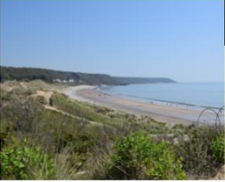
The aim of the project is to undertake a feasibility study to look at how Swansea Council operates its assets within the villages of Port Eynon and Horton on the Gower Peninsula. The study looked at council assets such as toilets, car parks, slipways and the public realm and engaged with local stakeholders, residents and tourists through-out the season. It will also look at opportunities focusing on innovative tourist ventures as well as ways of improving long term sustainability that benefits the local community and its economy. The feasibility study will be completed early 2019 and opportunities identified and acted upon once resources are made available.
Following on from the completion of this study we would have a working document that could be used to implement change as and when funding streams become available.
Businesses will benefit from improved infrastructure and services resulting in a better experience to those visiting the area. With improvements, more visitors will be encouraged to not only visit more frequently but stay longer contributing to an improved local economy.
The exit strategy for the project is on completion of the feasibility study we would have a working document that could then be used to implement changes to the destination as and when suitable funding becomes available.

Project Information:

Total Project Cost: | £7,700
Total EU/Welsh Government Funding: | £6,160

Mae’r ddogfen hefyd ar gael yn Gymraeg
This document is also available in Welsh

